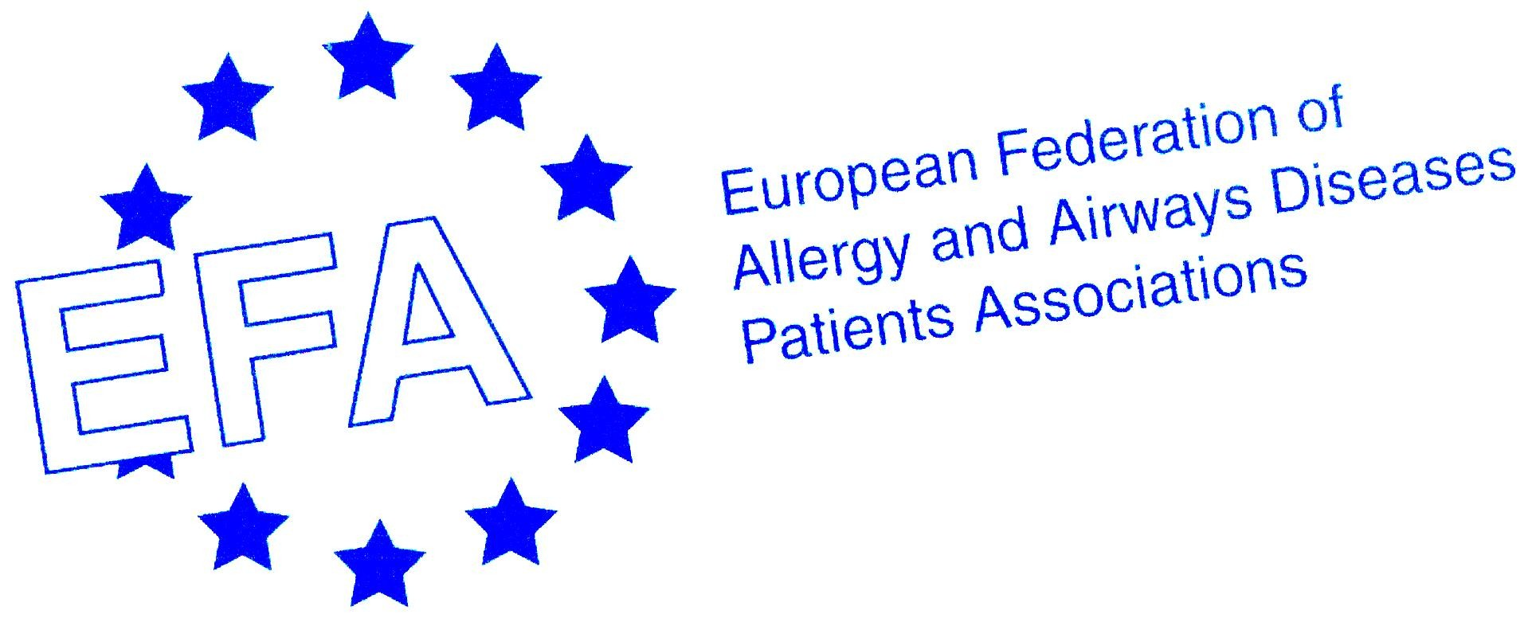

Reply form for EFA “Meet and Greet the European Union Institutions 2013” Training
Brussels, 15th-16st of October 2013

Please send the form to: roberta.savli@efanet.org by June, 10th 2013

General information

Name:

Address:

Telephone:

E-mail:

Nationality*:

ID or passport number*:

Date of birth*:

Organisation:

Arrival date:

Departure date:

Any food requirements:

Other needs:

* Information required to access the European Parliament

Specific information concerning the training

Are you a beginner (have you ever participated in other EFA trainings)? | YES | NO
Are you an advanced participant (have you already taken part in previous EFA trainings)? | YES | NO
For advanced participants: Are you planning to take part in the session “The role of stakeholders in Brussels” from 11:20 on the 15th? | YES | NO

