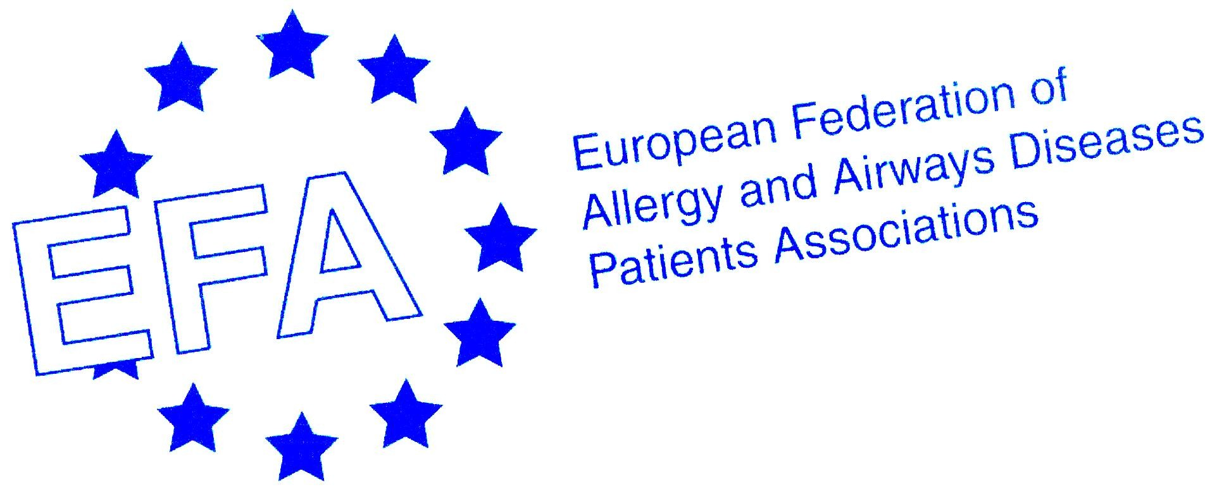

European Federation of Allergy and Airways Diseases Patients Association study visit to Brussels: Meet and Greet the EU Institutions

29-30 November 2007

Programme

This event is kindly sponsored by an unrestricted educational grant from Novartis.

Wednesday 28 November 2007

Arrival of delegates

Hotel du Congres (Nearest Metro is “Madou”)
Rud du Congres 42
1000 Bruxelles
Tel +32 2 217 78 90

Thursday 29 November 2007

VENUE: EFA Office, 35 Rue du Congrès, B-1000. Nearest Metro is ‘Madou’

08:50 | Arrival – Conference meeting room
09.00 – 09.15 | Welcome  Susanna Palkonen
09.15 – 10.00 | Presentation of the EU institutions related to health  Mariann Skar  This session will give a presentation of the European institutions and how it all works, the latest developments in the EU public health policies and the impact of other policy areas (internal market, agriculture, research, environment, health and safety etc) on public health.
10.00 – 12.30 | Bus to Luxembourg
12.30 – 13.30 | Lunch in Oberweiss
13.45 | Walk to HITEC building, meeting room 03/175
14.00 –14.45 | Presentation by and discussion with the Public Health Directorate, Health Determinants Unit  Giulio Gallo  This session will give an overview over the health determinants unit and their work related to patients with allergy and airway diseases, with a special focus on environment and health
14.45 – 15.15 | Presentation by and discussion with the Health Information Unit  Antoni Montserrat  This session will give an overview over monitoring, data gathering, reporting on health and the Working parties.
15.15 – 15.45 | Presentation by and discussion with the Public Health Executive Agency  Stephan Van den Broucke  This session will give a presentation of the Programmme of Community  Action on Public Health 2008 – 2013
16.00 – 16.30 | Presentation by and discussion with the DG Employment, Health and Safety Unit  Jorge Costa-David  This session will give an overview over what the Health and Safety at Work Unit does.
17.00 – 19.00 | Bus return to Brussels
20.00 | Dinner hosted by the sponsor, Keith Allan, Novartis  At Chez Leon, Rue des Bouchers 18, 1000 Brussels
Friday 30 November 2007

Venue: The EFA Office

09.00 | Mariann Skar  Morning coffee and outline of the day
09.15 – 10.45 | Walk to the European Parliament for a visit tour by Tamsin Rose
10.45 | Walk to the European Commission, Rue Froissart 101, meeting room 00/42
11.00 – 12.00 | Tobacco control developments in the EU and discussion  Thea Emmerling  This session will explore the role of the EU in tobacco control and recent developments on tobacco control at EU level including smokefree environments and the WHO Framework Convention on Tobacco Control (FCTC).
12.00 – 12.45 | Food Labelling initiatives in the EU and discussion  Helen Lee and Alexander Anton  This session will describe the way forward on food labelling and initiatives taken at EU level with special focus on allergens
13.15 – 14.00 | Sandwich Lunch at the EFA meeting room, Rue du Congres 35
14.00 – 15.00 | Presentation by the Health and Environment Alliance (HEAL) and discussion  Christian Farrar-Hockley  This session will focus on the main issues for HEAL that have impact on patients with allergy and airways diseases with special focus on the EU air pollution directive and the way forward.
15.30 | Review of study visit and departure of delegates

Your contact: Mariann Skar, EFA:
Mobile +32 4748 30041
Email mariann.skar@efanet.org

