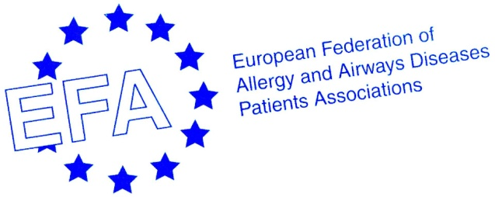

EFA “Meet and Greet the European Union Institutions 2013” Training
Date: 15th-16th of October 2013
Rationale: Thanks to this event, EFA members will have the opportunity to come to Brussels and learn about how the EU works and what the EFA network, as an organisation representing people with asthma, allergy and COPD in Europe can do to advocate their interests.
The “Meet & Greet 2013” combines basic and advanced training to participants. Beginners will discover the decision making process in the EU, main developments in the health policy at the European level and they will also be introduced to different roles stakeholders play here in Brussels. Together with advanced participants, they will meet and greet key actors from the Commission and the Council working on issues important to them, and also MEPs from their home countries. The role-play will enable all participants to dig deeper in the EU Tobacco Products Directive case study and replay the legislative process. Thanks to the workshop on air pollution they will get a first-hand experience of the European decision making process on the Commission’s proposal for the revision of the EU Thematic Strategy on Air Pollution.
Learning objectives: After completion, all participants will have improved knowledge of EU decision making and understanding of how the EU policies channel the decisions of the national governments. The role-play and the workshop will also deepen their knowledge of strategies and actors involved in the Tobacco Product Directive and the revision of the EU Thematic Strategy on Air Pollution, and how and why get involved. Last but not least, they will be empowered for the future on how patients’ organisation together with EFA can advocate their interests and take part in the EU legislative process.

Agenda
Day 0 – Monday, 14th October
Venue: Hotel du Congrès (42, rue du Congrès – B-1000, Brussels)
Late afternoon/Evening | Arrival of the first group of participants  Dinner
Day 1 – Tuesday, 15th October
Setting the scene
Venue: EFA office (35, rue du Congrès – B-1000, Brussels)
10:00 | Welcome by Susanna Palkonen, EFA Executive Officer
10:20 | - How does the EU work?, David Brennan, EFA Membership and Programme Officer  - The legislative process: basic introduction to decision-making  - Main actors: the role of the institutions and the Member States  - Q&A session
10:40 | - Health policy in the EU, Roberta Savli, EFA EU Policy Officer  - The division of competencies: who does what  - Main policy focus for 2013-2014: developments, events, expectations, progress  - Focus: the role of and patient involvement at the European Medicines Agency (EMA)  - Q&A session
11:00 | Coffee break  Possible arrival of the second group of participants
11:20 | - The role of stakeholders in Brussels, Susanna Palkonen and Kaisa Immonen-Charalambous, European Patients’ Forum (EPF), Senior Policy Advisor  - Common efforts with other similar organisations  - Focus: EFA and social media in the Brussels scene, David Brennan  - Q&A session
12:00 | Lunch  Possible arrival of the second group of participants
Meeting the European Parliament
Venue: European Parliament
13:00 | - Advocacy priorities for people with allergy and airways diseases, Roberta Savli  - Setting the scene: what are EFA’s priorities and what is currently under discussion within the institutions?
14:00 | - Visit to the Parlamentarium  - This interactive and informative visitors’ centre offers a refreshing new way to discover more about European institutions and integration. Thanks to handheld multimedia displays guides, visitors can learn more about the legislative process and the impact of European decision making on our everyday lives in all 23 EU official languages. The Parlamentarium features 360° surround-screen digital projection of the parliamentary chamber, a vast 3D lighting installation representing a shifting map of Europe, a virtual visit to all Member States or video messages from MEPs. The visit can take place before or after meetings with MEPs and is dedicated to members that have not visited it yet.
From 14:00 on | - Meeting MEPs from the participants’ countries  - Discussions around EFA’s and its members’ priorities under review within the institutions
19:00 | Dinner
Day 2 – Wednesday, 16th October
Working with specific legislative proposals: tobacco and air pollution
Venue: EFA office (35, Rue du Congres – B-1000, Brussels)
09:30 | Second day welcome – introduction of the programme and objectives
09:40 | - Workshop – Air pollution  - European Commission’s proposal for the revision of the EU Thematic Strategy on Air Pollution, Scott Brockett, European Commission, Directorate-General for Environment (DG ENV), Team Leader for Industrial Emissions, Air Quality and Noise (TBC)  - Greek Presidency of the European Union’s priorities in the field of air pollution – the view of next Council Presidency of the European Union, TBD  - Q&A session
10:40 | Coffee break
11:00 | - Role-play – Tobacco Products Directive  - Division of participants into different interest groups and EU institutions (EP and Council), replaying the legislative process  - Moderator: Roberta Savli
13:00 | Lunch
Evaluation: were the learning objectives met and proposals for future improvement
Venue: EFA office (35, Rue du Congres – B-1000, Brussels)
14:00 | - Evaluation, Roberta Savli  - Filling in the evaluation forms  - Suggestions for future steps, organisations, comments

