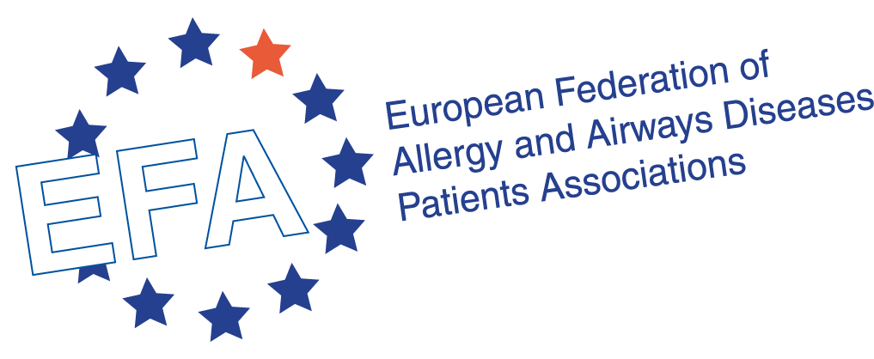

Report of EFA “Meet and Greet EU Institutions” Training 2015

The European Federation of Allergy and Airways Diseases Patients’ Associations (EFA) is a non-profit network of allergy, asthma and COPD patients organisations, representing 39 national associations in 24 countries and over 500,000 patients in Europe. EFA is dedicated to making Europe a place where people with allergies, asthma and chronic obstructive pulmonary disease (COPD) have the right to best quality of care and safe environment, live uncompromised lives and are actively involved in all decisions influencing their health. www.efanet.org

Introduction
On the 12th and 13th of October 2015, EFA organised its sixth annual training session for members. The training session focuses on the functioning of the European Union and policies related to the health of patients with asthma, allergy and COPD. The training was built upon the experience of previous years, 2007, 2009, 2012, 2013 and 2014. EFA has been organising this training as part of its strategy to involve members in the decision-making of EU policies. All programmes and previous reports are available here.
The goal of the training was twofold: on the one hand, it was aimed to give members an overview of the work of the European Parliament and the Council of the European Union in healthcare, and, on the other hand, to learn about funding opportunities provided by the European Commission, as well as communication strategies with policy-makers. The long term objective of this programme is to empower and assist member organisations to enable them to effectively advocate for their interests, both at EU and national levels. The programme for the event can be found here.
Eight members participated in the training:
- Marcia Podestà, Food Allergy Italia
- Giorgio Salerni, FederASMA e ALLERGIE onlus – Federazione Italiana Pazienti
- Bo Gleditsch, Norwegian Asthma and Allergy Association
- Javier Contreras, FENAER
- Armando Ruiz, FENAER
- Carla Jones, Allergy UK
- Jessica Edwards, Asthma UK
- Derry Begho, Asthma UK
President of the Czech Civil Association against Lung Diseases (ČOPN), Stanislav Kos, also took part in the training.

DAY 1:
Visit to the Council of the European Union
The participants visited the Council of the European Union – one of the key EU institutions, representing the executive governments of 28 EU Member States.
Juraj Sykora, Head of Unit on Public Health, Pharmaceuticals and Foodstuffs at the Council of the EU, provided a comprehensive overview of the Council’s role in the area of public health, as well as its functioning peculiarities in the context of the EU institutional setup.
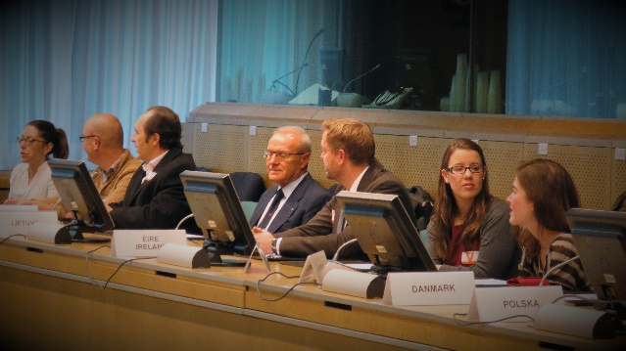
The speaker explained the legal basis for the EU action on public health, highlighting that despite the fact that health is a competence of Member States, the EU supports them and regulates on several aspects that impact patients’ lives by setting standards and procedures that need to be applied in all EU Member States.
Namely, the EU acts within three main public health domains: (1) prevention, (2) health protection/health security, (3) information and best-practices exchange/generation of knowledge. Juraj Sykora provided examples of the Council’s activities within the mentioned fields.
Health policy in the European Union: focus on the European Commission
Introducing the session on funding opportunities, provided by the European Commission, Roberta Savli, EFA Senior EU Policy Advisor, presented the role of the European Commission in the health policy of the EU, legislative background and public health priorities.

Horizon 2020
Silvia Anastasia, Project Advisor at Moverim Consultancy, presented to the group on funding opportunities in health under the Horizon 2020 programme.
Horizon 2020 programme is a financial instrument of the European Commission to support research and innovation in the EU.
The budget of the programme consists of several priority areas, and health falls within part of the budget foreseen to address societal challenges (38% of total budget).
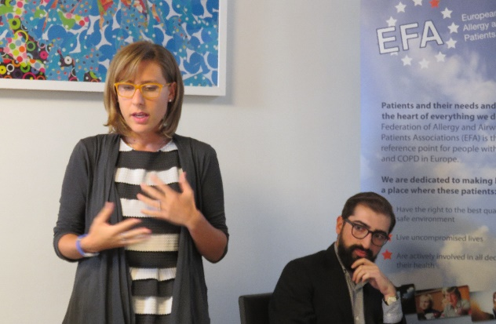
Main research priorities in health for 2015-2016 include: personalised medicine, human biomonitoring, maternal and child health, health ICT, infectious diseases and health ageing promotion.
Anastasia Silvia also explained the minimum conditions for participation in the calls for proposals under the Horizon 2020 and evaluation criteria.

Third Public Health Programme and Structural Funds
Giuseppe de Carlo, EFA Project Manager, presented funding opportunities of the Third Health Programme 2014-2020.
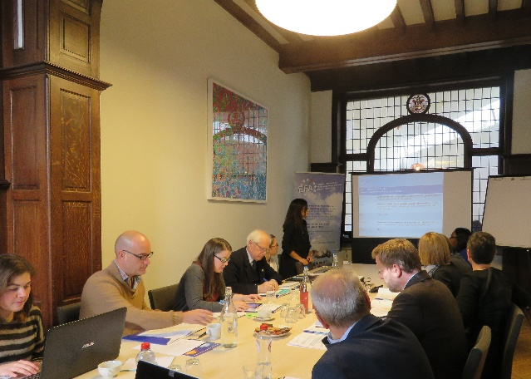The programme is the main instrument the European Commission uses to implement the EU health strategy. It is implemented by means of annual work plans which set out priority areas and the criteria for funding actions under the programme. The total budget for the programme is € 449.4 million.
Giuseppe de Carlo provided participants with an overview of rules for participation in the programme and also presented the Work Programme 2015 and opportunities to benefit.
The second part of the presentation was focused on other opportunities to benefit from public funding, such as: (1) the European Structural and Investment Funds, (2) the European Regional Development Fund, (3) the European Social Fund, (4) and the Cohesion Fund.

Workshop on how to apply or to be partner in EU projects
Jessica Edwards, Asthma UK EARIP Project Manager, together with Giuseppe de Carlo held a workshop on how to apply or be partner in EU projects.
The workshop included learning on EU funding opportunities, partner search service, national contact points and services and also discussion on other important administrative and financial aspects while considering to become a project partner.
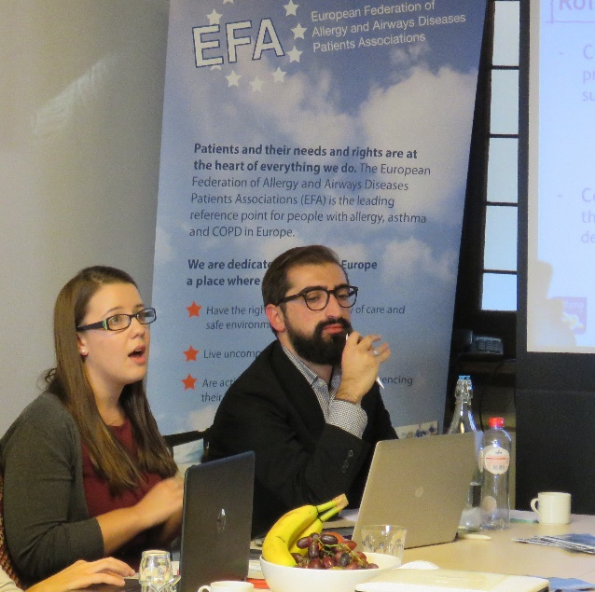

DAY 2:
The role of the European Parliament in shaping EU health policy
The second day of the training started from the presentation on European Parliament’s role in shaping EU health policy provided by Jelena Malinina, EFA Policy and Membership Officer. The participants were provided with an overview of the European Parliament’s composition, functioning and the work of EP Committee on the Environment, Public Health and Food Safety (ENVI). Moreover, ahead of the role-play, participants watched an educational video on co-decision procedure in the EU institutions.

Role-play: European Commission, European Parliament and Council of the European Union in practice
During the training, the participants received theoretical insights of the functioning of the Council, the Commission and the Parliament. The role play was organised to help the participants to get better understanding of practical aspects of decision-making at the EU level.
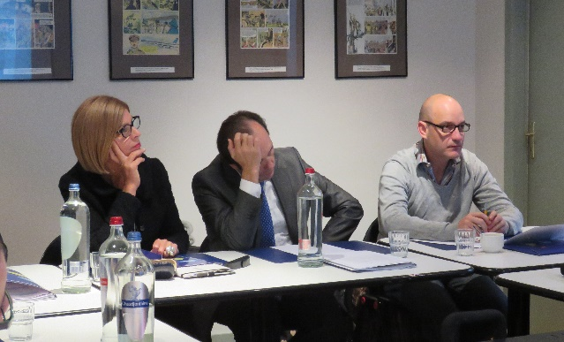
Members played the role of national Health Ministers, key Members of the European Parliament, Commission representatives and interested stakeholders in the role-play which simulated the European Commission’s imaginary proposal on introduction of mandatory smoke-free environments in the EU and co-decision procedure in the Council, Parliament and the Commission.

How and what to communicate to the European policy makers?
Ahead of the meetings with the Members of the European Parliament, Anne Kearney, EFA Communication Manager, Roberta Savli and Jelena Malinina provided the participants with tips on how and what to communicate to policy-makers.
Participants were also briefed on the most recent EFA’s advocacy actions and activities, including clean air social media campaign and the European Parliament Interest Group on Allergy and Asthma.

Meeting Members of the European Parliament
EFA members had the opportunity to meet and greet key Members of the European Parliament (MEPs) and to discuss asthma, allergy and COPD patients’ asks and needs at the national and European levels.
Giorgio Salerni from FederASMA e ALLERGIE onlus – Federazione Italiana Pazienti met with the assistant of Member of the European Parliament Sergio Cofferati (S&D).
Marcia Podestà from Food Allergy Italia met with MEP Patrizia Toia (S&D) and MEP Elisabetta Gardini (EPP).
Stanislav Kos from the Czech Civil Association against Lung Diseases met with vice-chair of ENVI committee, MEP Pavel Poc (S&D).
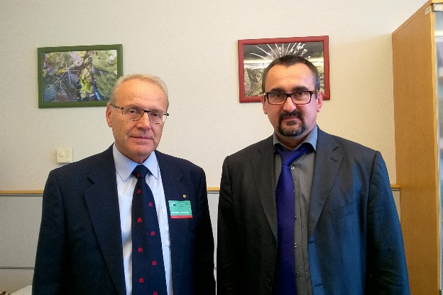

Javier Contreras and Armando Ruiz from FENAER met with MEP Pilar Ayuso (EPP).

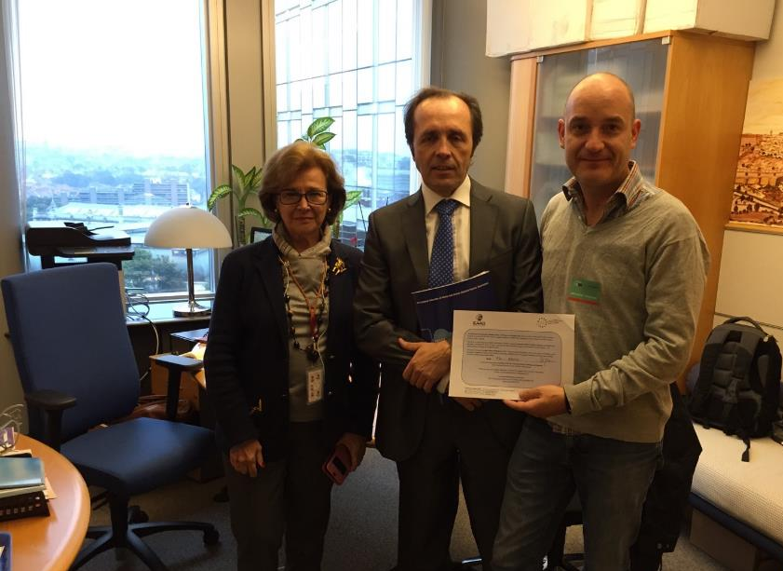

Conclusion and acknowledgments
The training was conducted in a very friendly atmosphere and despite the fact that many of the participants met each other for the first time, they were cooperating directly. Thank you very much for all your great work during the training!
A picture gallery of the training can be found on our EFA Facebook profile

