 | HORIZON 2020  Self management of health and disease:  citizen engagement and mHealth

Project:
myAirCoach - Analysis, modelling and sensing of both physiological and environmental factors for the customized and predictive self-management of Asthma"
(myAirCoach, Grant Agreement No. 643607)

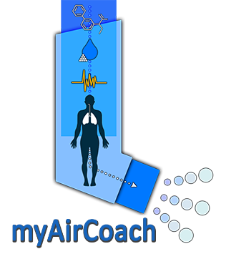

Deliverable number and title:
D7.1 Dissemination Plan and myAirCoach dissemination material
A journalistic description of the project understandable for the public.
Lead beneficiary: | EFA
WP. no, title  and activity type | WP7 – Dissemination and Exploitation (RTD)
Contributing Task (s) | T7.1 Dissemination activities, material and publication policy
Dissemination  level | PU ‐ Public
Delivery date | February 2015
Status | Working Draft
File name and  size | “myAirCoach-WP07-D7.1. Dissemination Plan and myAirCoach dissemination material_journalistic description_v6”

Authors List
Leading Author (Editor)
Name / Surname | Beneficiary Name (Short Name) | Contact email
Giuseppe De Carlo | EFA | Giuseppe.decarlo@efanet.org
Isabel Proano | EFA | Isabel.proano@efanet.org
Joke De Vocht | EFA | Joke.devocht@efanet.org

Executive Summary
This deliverable is a journalistic description of the myAirCoach project to ease the presentation of the project to the general public. This project description will inform the public in a detailed, but understandable way about myAirCoach’s objectives and plans. The journalistic description will be disseminated through the European Commission’s website and information material (brochure, leaflet) as well as through the project website.

Table of contents
Authors List 2
Executive Summary 3
Table of contents 4
Introduction 5
Who is involved? 6
Putting patients at the centre of asthma management 7
Why one size does not fit all 8
For more information 9

Introduction
This description has been created with the objective of reaching a wider audience through the dissemination activities planned along the project. Please find the description of the document below:

myAirCoach will help patients take control over their asthma by putting them at the centre of their disease management.

Who is involved?
The myAirCoach project consortium is composed of members from different functional areas in the field of healthcare that will work together to develop digital models, specific to each patient, that will monitor the patient’s condition and predict the progress of the disease.
The project is coordinated by the “Centre for Research and Technology Hellas” (Thessaloniki, Greece) that will partner with three research centres, three academic organisations, four private small and medium enterprises and two patient organisations.
Through the patient organisations, the project will count on a committee of patient volunteers that will be in continuous communication with the researchers. This committee will ensure that patients’ needs are taken into account for the entire project.

Putting patients at the centre of asthma management

Asthma is one of the most chronic diseases and affects 30 million people in Europe. Despite decades of research, asthma control remains poor because it is underdiagnosed, undertreated and difficult to predict.
myAirCoach is a new EU project aiming to overcome the gaps in asthma management. Under the coordination of the Centre for Research and Technology Hellas, myAirCoach researchers will develop a new mobile health system to help and support asthma patients to self-manage their disease with success.
Asthma control depends on many external factors that need to be measured. The personalised asthma monitoring system that will result from myAirCoach will have sensors to monitor the patient’s symptoms and triggers, the use of medication, environmental factors and.
People living with asthma have very sensitive muscles surrounding their airways. When their muscles get irritated, patients will experience breathlessness and wheezing. Thanks to myAirCoach sensors, the data collected from these symptoms will be transferred to a mobile device for analysis. The data will serve to create a personalized digital model of each patient’s condition and to match each patient to the right treatment plan.
Funded by the new EU Programme for Research and Innovation, Horizon 2020, myAirCoach will put patients at the centre of asthma management. Not only will they be involved in the research project itself, but the m-health tool resulting from the project will provide them with precious information on their day to day condition. This will bring the patient towards a (near) healthy lifestyle with the prevention of symptoms as the ultimate goal.

Why one size does not fit all
Asthma affects patients’ airways and, more specifically, the muscles surrounding their airway passage. When the muscles become irritated they clamp up, making breathing very difficult for asthma patients.
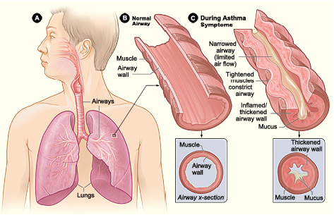
When asthma patients have an “asthma flare-up”, also known as exacerbation, the airways swell up, making it increasingly difficult to get the air both in and out of the lungs. The patient will no longer be able to properly exhale, leaving lungs still half full. This situation makes breathing in very painful: the lungs are over-inflated when the patient tries to breathe again, which results in hurtful stretching of the rib joints and chest muscles. Despite the lungs holding a lot of air, the air is stale, containing less than the average 20% oxygen, which explains why the patient will suffer from a shortage of breath.
Asthma is a difficult to treat disease, since it is influenced by many factors that might be out of the patient’s control:
- Age
- Genetic makeup: Gender, Genes …
- Bodily functions: Lung function, fitness …
- Behaviour: Use of medication, lifestyle, emotions …
- Environmental factors: Allergies, air pollution…

In addition to these parameters, the disease is also constantly changing. As a chronic disease, patients go through different stages that go along with different phases in their life, which makes every case of asthma unique.
Asthma patients need a treatment plan specifically tailored to their needs, because changing symptoms will lead to different treatment needs and options.

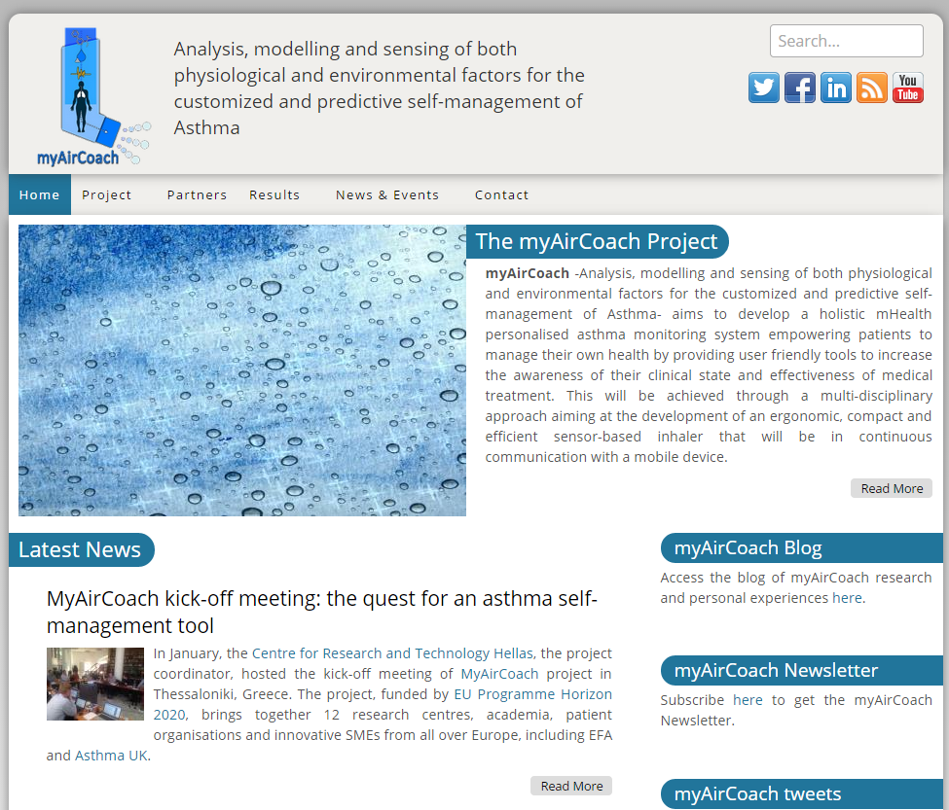
For more information
If you wish to know more on myAirCoach
(Analysis, modelling and sensing of both physiological and environmental factors for the customized and predictive self-management of Asthma), visit the project website: www.myaircoach.eu

