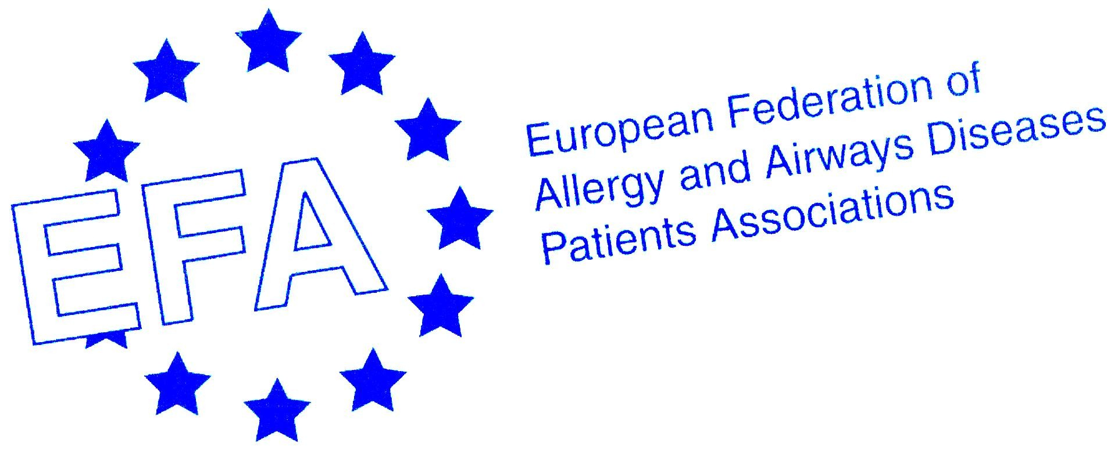

European Federation of Allergy and Airways Diseases Patients Association study visit to Brussels: Meet and Greet the EU Institutions

3rd – 4th December 2009

Programme

This event is kindly sponsored by an unrestricted educational grant from Novartis.

Wednesday

Arrival of delegates

Hotel du Congres (Nearest Metro is “Madou”)
Rue du Congres 42
1000 Brussels
Tel +32 2 217 78 90

Your contact: Mariann Skar, EFA:
Mobile +32 4748 30041
Email mariann.skar@efanet.org

Thursday 3rd December 2009

VENUE: EFA Office, 35 Rue du Congrès, B-1000. Nearest Metro is ‘Madou’

08:15 | Arrival and Welcome – Conference meeting room – departing for the European  Parliament
09:00 | Visit to European Parliament and participation in A European agenda for  Asthma and Allergies Conference, by the Parliament Magazine and GA²LEN  Opening chair – welcome speech Liz Lynne – MEP
09:20 | Session 1The issues  Torsten Zuberbier, Secretary General, GA²LEN  Breda Flood, Board Member, EFA  Jan de Monchy, European Union of Medical Specialities UEMS  Andrej Kobe, DG ENVIRONMENT, Clean air & Transport, European Commission  Anne Stauffer, Policy Manager, Health and Environment Alliance HEAL  Q&A
11:00 | Coffee
11:30 | Session 2 The way forward  Torstein Zuberbier, Secretary General of GA²LEN  Antonyia Paranova, MEP  Clare Mills, Leader of the Prevalence Cost and Basis of Food Allergy the  Europrevall project  Giulio Gallo, DG SANCO, European Commission  Q&A
13:00 | Lunch Reception at the European Parliament Members Salon
14.00 | Departure to European Council
14.30 – 16.00 | European Council visit tour  Tour and "The law making-decision process in the field of Public Health Policy"  by Ms. Rita Liudvinaciviute, Legal Service, Direction 1B in the General Secretariat of the Council of the European Union
16.00 – 18.30  Around 17:30 | Congregate to EFA Office  Feedback and questions - Meet the sponsor  If you have questions for Novartis as a company or their patient group relations, this is your chance.  Presentation by and discussion with the Public Health Directorate, Health Determinants Unit, Giulio Gallo  This session will give an overview over the health determinants unit and their work related to people with allergy and airways diseases, with a special focus on environment and health.
19:30 | Dinner hosted by Judith Robertson and Keith Allan from the sponsor, Novartis  Restaurant Vincent

Friday 4th December 2009

Venue: The EFA Office

09.45 | Morning coffee and outline of the day, Susanna Palkonen
10:00 – 10:45 | Presentation of the EU institutions related to health, Mariann Skar  This session will give a presentation of the European institutions and how it all works, the latest developments in the EU public health policies and the impact of other policy areas (internal market, agriculture, research, environment, health and safety etc) on public health.
10:45 | Networking coffee
11:15 | Departure to DG Health (SANCO)
12:00 – 12:45 | Tobacco control developments in the EU and discussion, Terje Peetso  This session will explore the role of the EU in tobacco control and recent developments on tobacco control at EU level including smokefree environments and the WHO Framework Convention on Tobacco Control (FCTC).
12:45 – 13:45 | LUNCH
14.00 – 14.45 | Food Labelling initiatives in the EU and discussion, Alexandra Nikolakopoulou  This session will describe the way forward on food labelling and initiatives taken at EU level with special focus on allergens.
15.00 | Walk back to the EFA office  Coffee and Review of study visit
16.00 | Departure of delegates

Please note there might be changes according to the availability of the speakers.

