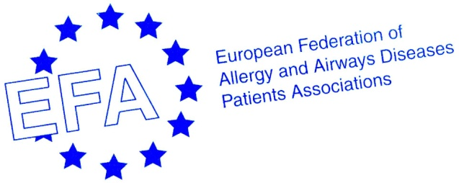

Annual General Meeting of the
European Federation of Allergy and Airways Diseases Patients’ Associations
EFA 20 years

AGENDA

6 May 2011, 12.30 – 18.30 including welcome lunch 12.00 onwards and refreshment breaks
Mercure Hotel Montmartre Sacre Coer, 3 rue Caulaincourt 75018 Paris, France.

- Opening and welcome and eligibility and procedure for voting.

- Approval of the agenda.

- Election of the Chairperson and Secretary to the Annual General Meeting and tellers for elections.

- Minutes of the previous Annual General Meeting, 27 May 2010. Attachment 1

- Membership requests.

- Motions by members and the Board.

- Activity Report 2010 - Year of the Lung In Memory of Mariadelaide Franchi. Attachment 2
- Presentation, Susanna Palkonen, EFA Executive Officer
In focus:
- EFA Food allergen labelling campaign, representative of the Food Allergy Working Group

- Accounts 2010 and Budget forecast. Attachment 3 a financial report, b auditor’s report, c budget 2011
- Presentation, Breda Flood, EFA Treasurer

- Strategy. Attachment 4
- EFA EU Policy objectives and projects - The link to the future, Susanna Palkonen
In focus:
- ‘EFA member involvement and improving outcomes at EU level’, report by Members Steering Group

- Work plan 2011. Attachment 4
- Summary presentation, Christine Rolland, EFA Vice President
Projects in focus: member involvement and impact at national level
- EFA flagship projects 2011, Antje Fink-Wagner, EFA Project and Fundraising Officer, Project coordinator
  - Allergy project: Working title: Respiratory Allergy (former ‘Allergy is a chronic disease programme’)
  - COPD Project: Follow up project on the EFA Call to Action on COPD for Europe: roundtables at the European Parliament
- EFA Global project: Global Asthma and Allergy Patient Platform GA²PP, Antje Fink-Wagner, EFA GA²PP coordinator
- EFA partnership projects:
  - MedALL Mechanisms of the Development of Allergy, Per-Åke Wecksell, EFA Board Secretary and MeDALL lead
  - AIRProm Airway Disease PRedicting Outcomes through Patient Specific Computational Modeling, Susanna Palkonen
- New website, Lina Buzermaniene, EFA Board Member

- Membership fee.
The Board proposes to keep the Membership fee at 1.500 € / member organisation/coalition 2011.
- New membership fee structure 2012 proposal from the Board, Marianella Salapatas, Attachment 5

- Appointment of the auditor.
For auditor Sara Ceusters, ICount4You, Belgium, EFA long term audit firm is proposed by the
Board.

- Election of Board members 2011-2013. Attachment 6
President and 2 board members will be elected.
- Presentation of voting procedure, Marianella Salapatas
- Presentation of Candidates

- 20 EFA Years
- The first 17 years, past presidents Erkka Valovirta and Svein Erik Myrseth and honorary members Elisabeth Bell and Arne Heimdal
- The following 3 years, Marianella Salapatas, President

14. Closing of the Meeting.

*all presentations will be short and leaving time for discussion

Attachments
1 Minutes of the AGM 2010
2 Activity report 2010
3 a Financial report 2010, b Auditor’s report 2010, c Budget 2011
4 Work plan and strategy 2011
5 New membership fee structure 2012
6 Board candidates

The AGM is followed by EFA anniversary dinner and Network meeting 7 May 9.-16.00

