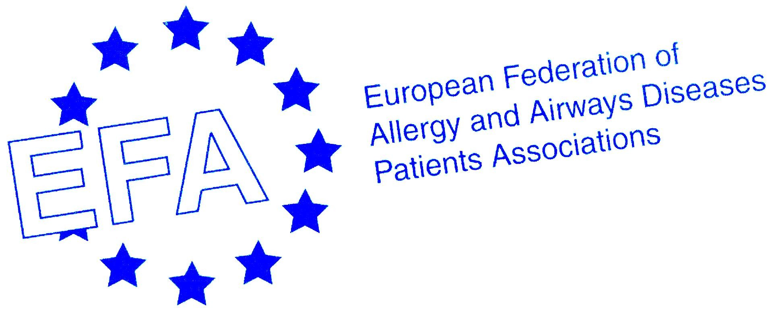
WORLD ASTHMA DAY 2004

BURDEN OF ASTHMA IN EUROPE

On World Asthma Day 4 May 2004 GINA Global Initiative for Asthma published their Global Burden of Asthma report. The report is based on standardized data collected in epidemiology studies in more than 80 countries.

Prevalence
1 in 20 people in the world, 300 million people and over 30 million in Europe have asthma and the burden to governments, health care systems, families, and patients is increasing.

Asthma is one of the most common chronic diseases in the world and has increased in recent decades in both children and adults around the world. It is estimated that an additional 100 to 150 million persons are likely to have asthma by 2025 with the projected increase of world’s urban population from 45% to 59%.

Causes
The increase has been associated with an increase in atopic sensitization, and is paralleled by similar increases in other allergic disorders such as eczema and rhinitis.
The causation of asthma is not known; therefore research into the causation and efficacy of primary and secondary intervention strategies are key priority areas in the field of asthma research.
The rate of asthma increases as communities adopt western lifestyles and become urbanized.

DALYs and mortality
In many areas of the world persons with asthma do not have access to basic asthma medications or medical care. The number of disability-adjusted life years (DALYs) lost due to asthma worldwide has been estimated to be currently about 15 million per year, equivalent to 1% of all DALYs. It is estimated that asthma accounts for about 1 in every 250 deaths worldwide. Many of the deaths are preventable, being due to suboptimal long-term medical care and delay in obtaining help during the final attack.

Economic and social cost
The economic cost of asthma is considerable both in terms of direct medical costs (such as hospital admissions and cost of pharmaceuticals) and indirect medical costs (such as time lost from work and premature death).
When a person’s asthma is not under control, the economic and social costs of the disease are greatly increased. If not effectively treated, asthma often leads to hospitalization, missed work and school, limitations on physical activity, sleepless nights and in some cases death.

Control
With proper diagnosis, good treatment and effective management, asthma can be controlled and the person with asthma can lead a full and active life. This requires the collaboration of governments, healthcare professionals and patients. There are many examples of success in fighting asthma. Public health programs and education campaigns in several countries around the world have decreased asthma mortality and the burden of disease. Local adaptations of international guidelines, GINA, ARIA, show how asthma management programs can be tailored to fit the local culture and the level of resources available.

The GINA guidelines (www.ginasthma.com) define the goal of treatment as follows:
- Minimal, ideally no chronic symptoms, including nocturnal symptoms
- Minimal or infrequent episodes
- No emergency visits
- Minimal need for rescue medication
- No limitations on activities, including exercise
- Near normal peak flow, and variability in peak flow of less than 20%
- Minimal or no adverse effects from medicine
The ARIA guidelines (www.whirair.com) provide strategies for managing the effect of coexistent allergic rhinitis in asthma.

The EFA Ten rules for coping with asthma aim at the empowerment of patients to take control over their disease:
1. Accept your asthma
2. Have respect to your breathing
3. Make others respect your breathing
4. Improve your knowledge of the disease
5. Have a good partnership with your doctor
6. Take part in defining the therapeutic plan
7. Comply with treatment
8. Undergo regular medical controls
9. Prevention: avoid triggers or take measures to reduce the risk
10. Join an asthma patient’s association

Barriers to Reducing the Burden of Asthma from GINA
1. Generic: poverty, poor education, and poor infrastructure.

2. Environmental: indoor and outdoor air pollution, tobacco smoking, and occupational exposures.

3. Low public health priority due to the importance of other respiratory illnesses such as tuberculosis and pneumonia and the lack of data on morbidity and mortality from asthma.

4. Lack of symptom-based rather than disease-based approaches to the management of respiratory diseases including asthma.

5. Unsustainable generalizations across cultures and health care systems which may make management guidelines developed in high-income countries difficult to implement in low-income countries.

6. Organisation of health care services in terms of geography, type of professional responding, education and training systems, public and private care and tendency of care to be "acute" rather than "routine."

7. Limited availability and use of medications including omission of basic medications from WHO or national essential drug lists, poor supply and distribution infrastructure, cost, cultural attitudes towards drug delivery systems, e.g. inhalers and overuse or ineffective use.
Prevalence of Asthma in EFA Member countries % population

Country | CHILDHOOD Self-reported wheezing* | CHILDHOOD Asthma symptoms  (clinical)** | Asthma Symptoms in ADULTS*** | CLINICAL ASTHMA
Denmark  Finland  Lithuania  Norway  Sweden  U.K.  Ireland  Austria  Belgium  France  Germany  Italy  Luxembourg  Netherlands  Portugal  Spain  Switzerland  Greece  Slovenia  Bulgaria  Czech Republic  Hungary  Serbia and Montenegro | 6  17  -  13  13  32-38  29  11  12  13  13  8  -  -  10  11  5  3  -  -  -  -  not included in the study! | -  5  -  -  5  -  -  6  -  9  6  6  -  -  7  8.5  -  -  -  -  -  - | 25  20  -  25  20  25-30  28  14  17  14  17  10  -  20  18  22.5  17  17  -  -  -  - | 3  8  -  6.8  6.5  15.3-18.4  14.6  5.8  6  6.8  6.9  4.5  -  -  4.8  5.7  2.3  1.9  -  -  8  -

- no standardized data available
*Written Questionnaire: Self-reported wheezing in the previous 12 month period, in 13- to 14-year-old children
**Video Questionnaire: Positive response to clinical asthma scene in 13- to 14-year-old children
***Written Questionnaire: Self-reported wheezing in the previous 12 month period, in 20- to 44-year-old adults
*,**,*** The figures are EFA interpretation on the graphics in the report!!!

Study regions in the report have been classifies as follows (EFA member countries in black)
Please see the report for summaries for each region!!!
1. Scandinavia/  Baltic States  Denmark  Estonia  Finland  Lithuania  Norway  Sweden  Iceland  Latvia  Poland | 2. United Kingdom/  Republic of Ireland  England  Guernsey  Isle of Man  Jersey  Northern Ireland  Republic of Ireland  Scotland  Wales | 3. Western Europe  Austria  Belgium  France  Germany  Italy  Luxembourg  Netherlands  Portugal  Spain  Switzerland | 4. Balkans/Turkey/Caucasus/  Mediterranean Islands  Greece  Slovenia  Albania  Armenia  Azerbaijan  Bosnia-Herzegovina  Croatia  Cyprus  Georgia  FYR Macedonia  Malta  Serbia, Turkey | 5. Russia & Former Socialist Republics of E. Europe  Belarus  Bulgaria  Czech Republic  Hungary  Moldavia  Romania  Russian Federation  Slovakia  Ukraine

