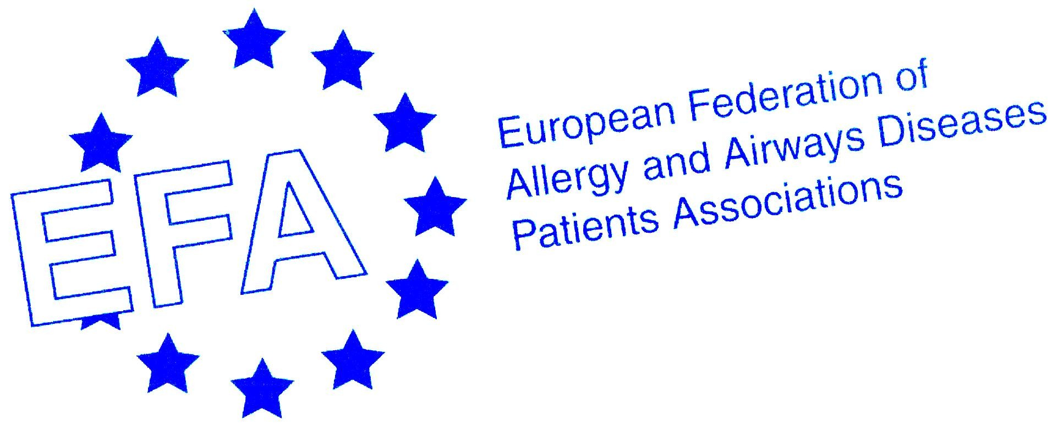
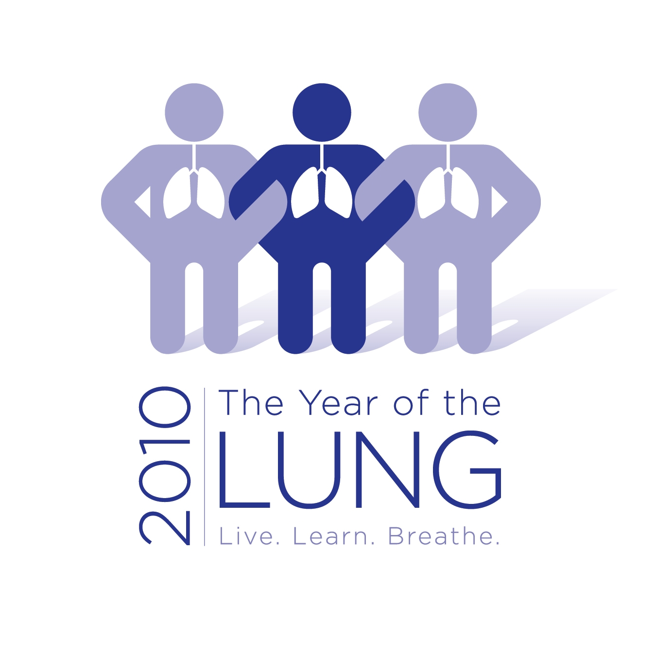

Will Europe suffocate or breathe? A CALL TO ACTION TO COMBAT COPD IN EUROPE

Chronic Obstructive Pulmonary Disease (COPD) is a leading cause of death, and affects approximately 210 million people. Despite this, COPD remains insufficiently recognised, diagnosed, prevented and treated in Europe. We, the undersigned, call upon the European Union (EU) to take the necessary steps to develop a strategic, comprehensive and integrated European approach to respiratory diseases with a focus on COPD which brings all initiatives and actions under one umbrella, and supports the launch and implementation of national plans on COPD.

We assert that the following actions should be supported by the European Parliament, European Commission and European Council:
- Make COPD a political priority
- Increase awareness of COPD
- Prioritize the early diagnosis of COPD
- Support an integrated and multidisciplinary patient-centered approach to the treatment of COPD to improve the care and management of COPD
- Prevent COPD
- Improve Air Quality
- Support better understanding and management of COPD through research

1. Make COPD a political priority
- COPD affects approximately 210 million people worldwide, and according to WHO estimates COPD will become the third leading cause of death by 2030. In Europe 4-10% of adults have COPD. The total financial burden of COPD in Europe amounts to nearly €102 billion and it is expected to increase. Moreover, the social burden of COPD is also increasing; in particular, 21% of COPD patients are severely disabled. COPD is implicated in about 5% of deaths. Despite disabling symptoms (especially breathlessness), complex co-morbidities, and social isolation, the needs of people with very severe COPD are rarely adequately addressed.

- The prevalence of tobacco smoking, which is the most important risk factor for COPD, is still high. Outdoor and indoor air quality remains poor in many urban areas. At the WHO 5th Ministerial Conference on Environment and Health, the Commission rightly highlighted the negative impact of bad air quality on children which can lead to chronic respiratory conditions.

- We call upon the European Commission to recognise COPD as an urgent, preventable and real public health problem and to adopt a comprehensive and integrated approach to address these problems in order to improve the quality of life of patients, decrease the social and economic burden of the disease and stop the COPD epidemic.

2. Increase awareness of COPD
- COPD is a chronic common lung disease that obstructs the airways making breathing difficult. The worse COPD is, the more difficult it is to breathe, with those at the end stage of the disease on permanent mechanical ventilation. Unfortunately, COPD is vastly underrepresented in the mass media and very few people have heard about it. It is crucial that people in every Member State know about COPD but also that patients and their families have easy to understand information on the disease, prevention, and treatment.

- We call upon the EU/National Ministries of Health to implement large-scale public health campaigns to increase awareness of COPD amongst the general public, General Practitioners and patients about the symptoms and risk factors (especially smoking) associated with COPD in order to prevent the disease and to encourage an early diagnosis.

3. Prioritize the early diagnosis of COPD
- The later the diagnosis, the more severe the disease. An early and accurate diagnosis of COPD allows for timely treatment and lifestyle changes that can prevent the progression of the disease and its associated premature morbidity and mortality. Despite this, access to early diagnosis of COPD remains difficult in many countries across the EU. This is in-part due to the lack of necessary COPD screening equipment.

- Spirometry is the equipment which tests the lung function, and is a cost-effective, easy to use and non-invasive test which can be performed routinely by General Practitioners. Spirometry should be made available across health services in all EU Member States and should become a normal part of regular health checks.

- We call on the EU to promote and share best practices on early diagnosis and the national authorities to take their responsibilities and ensure that early diagnosis of COPD is undertaken, and General Practitioners are willing and able to perform the appropriate diagnostic tests.

4. Support an integrated and multidisciplinary patient-centered approach to the treatment of COPD to improve the care and management of COPD
- COPD is preventable and treatable, but is in most countries the treatment is only partly reimbursed. COPD places a considerable social and economic burden on patients, their families and the whole society. Access to treatment, continuity of care, and rehabilitation, effective self-management programmes are essential for the optimal management of chronic respiratory diseases.

- Patients with advanced COPD have worse quality of life, greater limitation of activity, more anxiety and depression than patients with lung cancer, yet access to palliative care services is rare.

- Many COPD patients die during an exacerbation, and it is important to develop management strategies before a crisis occurs.
We call upon the EU to adopt measures in support of ensuring and sharing best practices on the best standards of care for COPD patients at every level, from primary care to specialist healthcare . This includes equal access to treatment, palliative care, patient information and education and rehabilitation programmes for all COPD patients and treating patients and patient representatives as equal partners in their care and health policy.

5. Prevent COPD
- Early COPD symptoms are often mistaken by people as ‘just a normal part of ageing’, or ‘just a smokers cough’, without recognizing that these are early stages of COPD. Diagnosing COPD early would greatly lessen the economic and social burden of the disease on already-stretched health systems.

- Smoking is the main cause of COPD and passive smoking can cause and severely aggravate the condition of people with COPD, yet very few people who start or continue smoking know about COPD, like they do about lung cancer – both having devastating impact.

- We call upon the EU and Member States to put in place prevention campaigns and initiatives, in order to reduce the risk of COPD.

6. Improve Air Quality
- 19 000 European non-smokers die every year from exposure to second-hand smoke either at home or at the workplace. According to recent Eurobarometer survey a quarter of non-smokers are exposed to tobacco smoke at home and a quarter of EU citizens are exposed to tobacco smoke at work.

- Poor indoor air quality (such as damp or mouldy buildings) is particularly harmful for people with COPD. Air pollutants like dust, or fumes can also irritate the lungs and cause exacerbations.

In the WHO European Region, “70% of the population lives in urban areas, and over 92% of city dwellers are exposed to levels of particulate matter that exceed the WHO air quality guideline value”. The peaks of pollution can be devastating for people with COPD.
- We call on the EU and the Member States to ensure improved outdoor and indoor air quality, including binding measures to abolish smoking in both the work place and public places across Europe and a joint framework on healthy air indoors.

7. Support better understanding and management of COPD through research
- There are a number of research questions that need to be addressed before care for people with COPD can be at the same level as other chronic diseases. These include questions about prevention, diagnosis, case-finding and spirometric assessment in primary care, management and organization of care, and support and palliative care for patients with severe COPD.

- COPD together with asthma is the most common lung disease, yet mechanisms behind the development of COPD are poorly understood and there is no cure. EU research must focus on understanding the mechanisms in the development of this major disease.

- Availability and comparability of COPD prevalence data in Europe is poor leaving important gaps of knowledge.

- Research makes a direct contribution to the prevention and treatment of COPD and can lead to increases in the quality of life of European citizens.

- We call on the EU and Member States to prioritize investment in real life, basic and prevalence research in respiratory diseases and prevention, to ensure that effective treatments and cures can be developed.

SIGNED by
EFA PARTNERS:
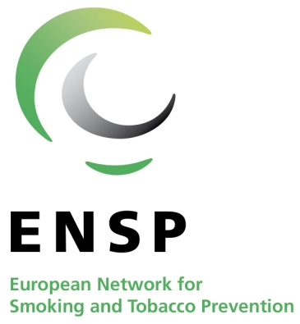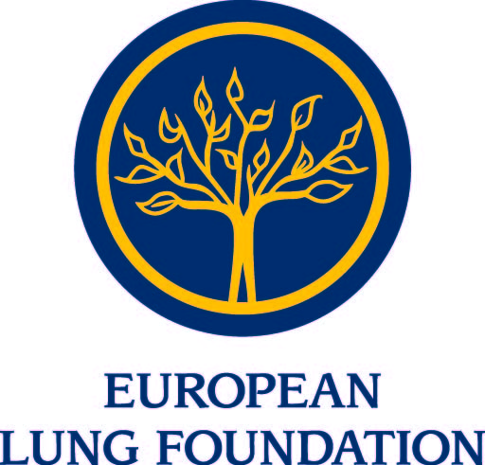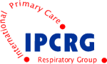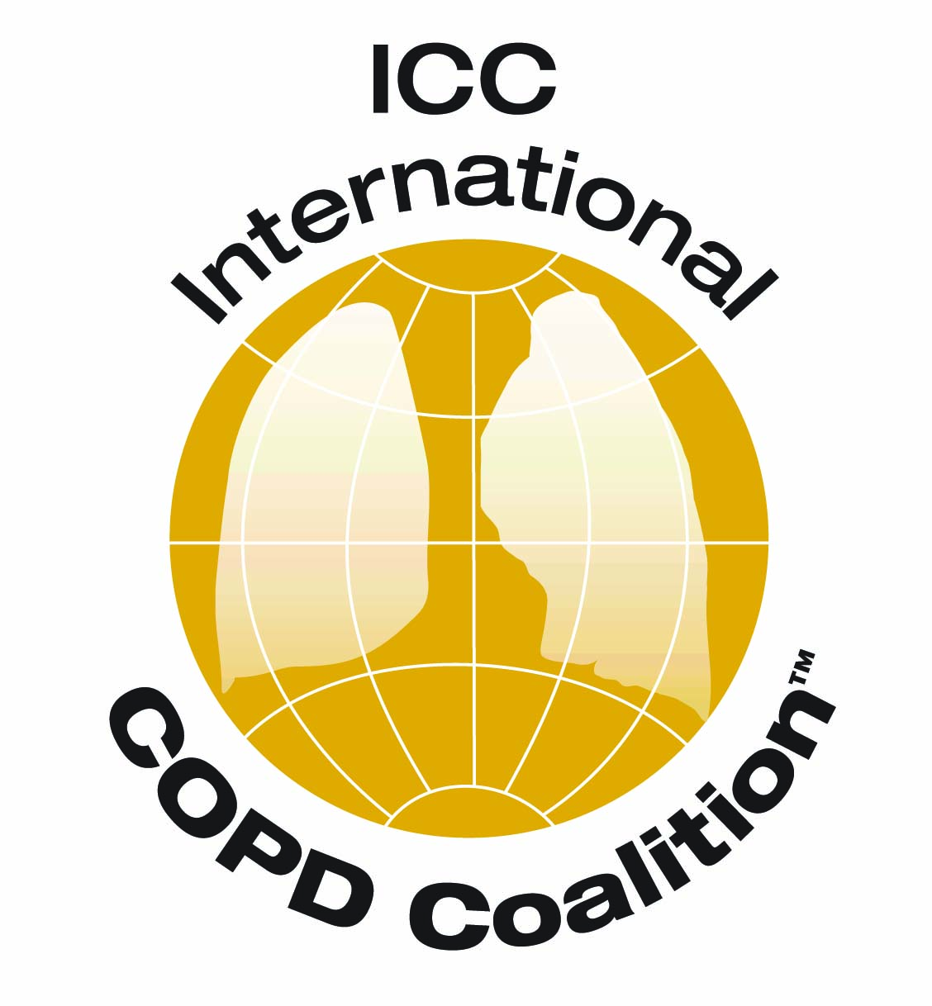

Source: WHO Europe: http://www.euro.who.int/mediacentre/PR/2010/20100406_1

