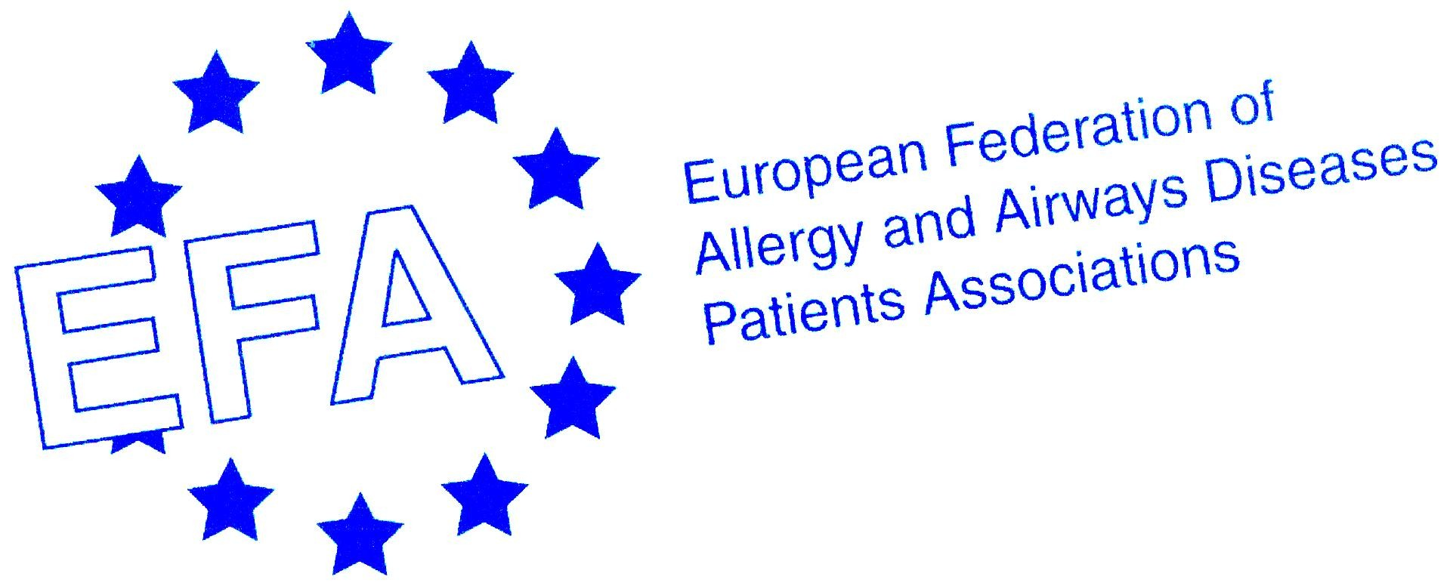

Chronic Obstructive Pulmonary Disease (COPD):
The 4th Leading Cause of Death in Europe
-A European Problem with European Solutions-

COPD In Europe
Around 44 million people in Europe live with chronic obstructive pulmonary disease (COPD). COPD is ranked as the fourth leading cause of death in Europe and the LEADING cause of healthcare costs in the EU. Despite this, COPD is not well-known.

COPD is a progressive, debilitating and often life-threatening disease that affects the patient’s ability to breathe, gradually making breathing more difficult. COPD is preventable and treatable!

On the occasion of World COPD Day 2009, EFA launched its Book on COPD in Europe ‘Sharing and Caring’ which gives an unprecedented collection of data on the quality of care, disease management, and social and financial burden of COPD in Europe. The book highlights the serious shortfalls in diagnosis and care that exist today between Member States.
Following the EU Open Health Forum, EFA is gathering all key stakeholders at the European Parliament to highlight the urgent need to reduce the suffering and mortality linked with COPD, which according to the WHO, will become the third leading cause of death worldwide by 2030 – if not tackled appropriately.

The theme of the Open Health Forum is ‘Health in All Policies’. Allergic and respiratory diseases including COPD serve as testament to this necessity. Health must play an integral part in policy development. Policies affecting indoor and outdoor air quality, climate change, tobacco control and second hand smoke are good examples. Health in all policies supports comprehensive patient centred care and prevention and can help to revolutionise lives of European citizens and particularly those living with COPD.

EFA is co-coordinating a workshop on environment and health during the Open Forum where the patient voice on allergy, asthma and COPD will be heard and serve to shape future policy including the EU 2020: "A Vision for Health to the EU 2020".

PROGRAMME

- Registrations - 17.30 – 18.00

- Opening, Catherine Stihler, MEP, Chair - 18.00
As a devoted advocate on COPD and other respiratory diseases, Catherine will moderate the debate and help steer the discussion towards realistic conclusions on what Europe can do to better the lives of those living with COPD.

- Written Foreword by Jerzy Buzek, President of the European Parliament - 18.10
The foreword of President Buzek which introduces COPD as a major public health problem in Europe will be introduced. Mr Buzek was the Parliament rapporteur who ensured the inclusion of respiratory allergic diseases in the 7th EU R&D Framework Programme. His words will set the scene for the event whilst emphasising how Europe can add value to the work of Member States by conducting research and translating the results into raising awareness, promoting early diagnosis and developing policies that reduce suffering and enhance lives.

- Addressing COPD – a Commission perspective, Michael Huebel, Head of Unit Health Determinants, European Commission DG Health and Consumer Affairs - 18.15

- A Snapshot of COPD in Europe, Jean Ann Gilder, Project Coordinator of the EFA Book of COPD in Europe – Sharing and Caring, member of the Italian Association of COPD Patients- 18.30
Ms. Gilder will present key findings from the COPD Book, written by patients for patients, including facts of COPD in 12 European countries, impact on economy, access to care, quality of care, actions promoting healthy environment, special national successes and challenges in managing COPD and showcases patient groups’ best practices and projects across Europe.

- My COPD, A Patient Perspective, Allan Stone -18.45
Mr. Stone, a patient with COPD will share his story on living and managing COPD every day, before and after diagnosis.

- A Call for European-Wide Surveillance of COPD, Nikos Siafakas, ERS President & Coordinator of the Year of the Lung European region - 18.55
Prof. Siafakas will introduce the current gaps in monitoring COPD across Europe and make the case for an European-wide Surveillance System such as that in antimicrobial resistance EARSS.

- Announcement of a European Call to Action on COPD, Marianella Salapatas, EFA President - 19.10
Based on the state of play of COPD in Europe Ms. Salapatas will introduce the key action points for a ‘road map on COPD’ and ask support for genuine coordinated action to counteract COPD in Europe by the European Parliament, Commission and the Member States in synergy with patient groups, healthcare professionals, other NGOs and stakeholders.

A cocktail and finger food will be served throughout the event

This event is part of the Year of the Lung 2010 initiative – In Memory of Mariadelaide Franchi.

The event is kindly supported by unrestricted educational grant from EFA sustainable funding partners Boehringer Ingelheim & GSK.

