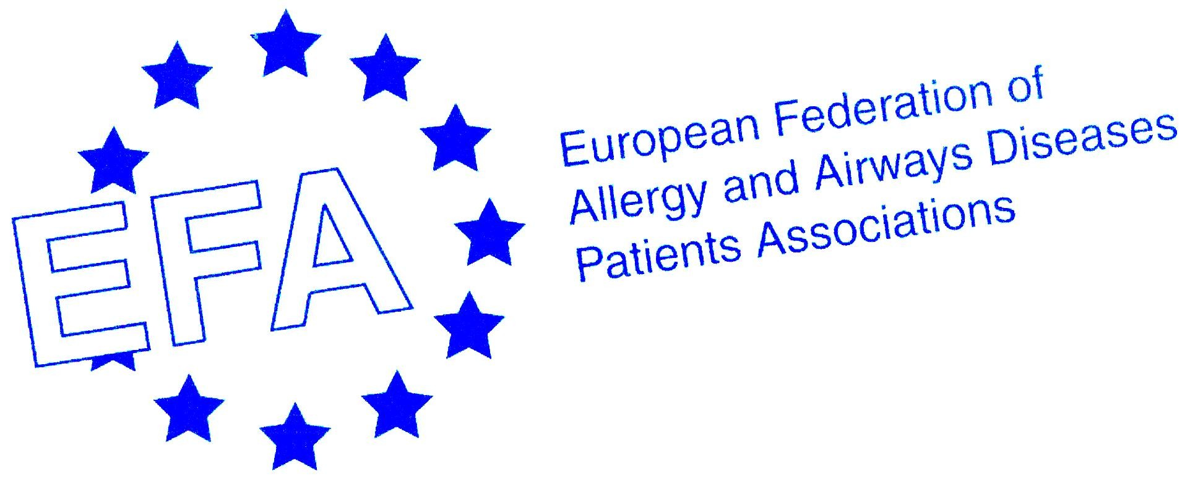

Chronic Obstructive Pulmonary Disease (COPD):
The 4th Leading Cause of Death in Europe
-A European Problem with European Solutions-

COPD In Europe
Around 44 million Europeans live with chronic obstructive pulmonary disease (COPD). It is ranked as the fourth leading cause of death in Europe and the LEADING cause of healthcare costs in the EU.

COPD is a progressive, debilitating and often life-threatening disease that affects the patient’s ability to breathe, gradually making breathing more difficult. Without breathing, there is no life. COPD is a preventable and treatable!

On the occasion of World COPD Day 2009, EFA launched its Book on COPD in Europe. ‘Sharing and Caring’ which gives an unprecedented collection of data on the quality of care, disease management, and social and financial burden of COPD in Europe in 12 countries. The book highlights the serious shortfalls in diagnosis and care that exist today between Member States from patient perspective.
On the eve of the EU Health Policy Open Forum, EFA is gathering all key stakeholders here at the European Parliament to highlight the urgent need to reduce the suffering and mortality linked with COPD, which according to the WHO, will become the third leading cause of death worldwide by 2030 – if not tackled appropriately.

The theme of the Health Policy Open Forum is ‘Health in All Policies’. Allergic and respiratory diseases including COPD serve as testament to this necessity. Health must play an integral part in policy development. In the field of allergic and respiratory diseases EU policies on indoor and outdoor air quality, climate change, tobacco control, second hand smoke, and food labelling can revolutionise European citizens lives and particularly those living with COPD.

EFA is involved in a workshop on environment and health during the Open Forum where the patient voice in allergy, asthma and COPD is one key perspective and hopefully serve to shape future EU policy including ‘the EU2020: "A Vision for Health to the EU 2020".

30 June 2010 DRAFT PROGRAMME

- Opening, Catherine Stihler, MEP, Chair

- Introduction-Making EU Research Meaningful, Jerzy Buzek, President European Parliament - invited

- A Snapshot of COPD in Europe, Jean Ann Gilder, Project Coordinator of the EFA Book of COPD in Europe – Sharing and Caring

- My COPD, A Patient Perspective, Patient with COPD

- A Call for European-Wide Surveillance of COPD, Nikos Siafakas, ERS President & Coordinator of the Year of the Lung European region

- A Comprehensive EU Strategy for COPD– Making Vision Reality, John Dalli, European Commissioner for Health - invited

- Announcement of European Declaration on COPD, Marianella Salapatas, EFA President
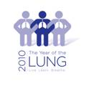

This event is part of the The Year of the Lung 2010 initiative. It is kindly supported by an unrestricted
educational grant from EFA sustainable funding partners Boehringer Ingelheim and GSK
For enquiries about this event, please contact: info@efanet.org

