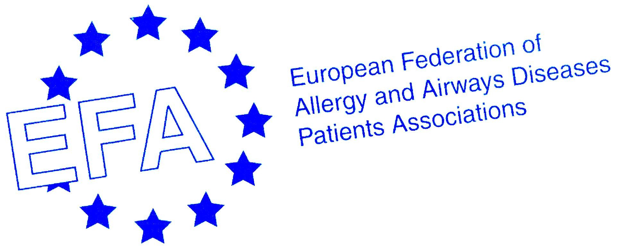

GA²P² Declaration of Buenos Aires*
*Global Allergy and Asthma Patient Platform

We, allergy and asthma patients, patient care givers and patient advocates from xy countries around the world declare

- Global networking of allergy and asthma patient organizations is needed.
We will establish a network to empower the patient voice. We demand to be equal partners involved in decision making, from inception to conclusion, with global health care organizations such as ARIA*, GINA**, GOLD***, WAO****, and WHO- GARD*****.

- All patients with allergies and asthma have a right to comprehensive health care.
Best practice therapy includes early diagnosis, patient centred care, access to medication, regular follow-up and rehabilitation. These must be globally agreed, locally adapted, widely disseminated and implemented.

- Access to education including information, training and self management plans is mandatory in best practice therapy. Participation in decisions of their own care is essential for allergy and asthma patients to facilitate adherence.

- Patients with allergies and asthma demand to live in healthy unpolluted air and smoke-free environments. They have the right to accurate information on allergens and other substances that aggravate their disease.

- Patients with allergies and asthma have the fundamental responsibility to take an active role in managing their disease and to lead a healthy life style to allow no limitations to their life and daily activities.

Patients’ families, caregivers and health professionals must be empowered to support patients to manage their allergies and asthma.

We as GA²P² will work for this on a global level. Action is needed and our network will work unceasingly to achieve this goal.

Signed and published December 8, 2009 during XXI World Allergy Conference WAC by

Natalio Salmun,
President and Valeria Araujo, Patients Commission of Fundaler, ARGENTINA

Garry Irving
Services Manager, Asthma Foundation of Victoria, AUSTRALIA

Caroline Polak Scowcroft
Deputy Chair of the Australian Lung Foundation COPD Patient Taskforce & Vice President Health Care Consumers Association of ACT, AUSTRALIA

Otto Spranger
Board member and manager of the Lungenunion, AUSTRIA

Zuleid Dantas Linhares Mattar
Managing Director of the Brazilian Association of People with Asthma and President of COPAR, BRAZIL

Bill Swan
Deputy CEO, National Asthma Patient Alliance NAPA, CANADA

Ondrej Rybnicek
Vice President EFA, Czech Initiative for Asthma CIPA, CZECH REPUBLIC

Erkka Valovirta
Past President EFA, EFA Medical Advisor, Advisory Board Member of the Finnish Asthma & Allergy Foundation, FINLAND

Christine Rolland
Director Association Asthme & Allergies, FRANCE

Antje-H. Fink-Wagner
EFA Funding and Project Officer, GERMANY

Marianella Salapatas
EFA President and ANIKSI Board member, GREECE

Marcia Podesta
President Food Allergy Italia, ITALY

Michael Levin
President, Refiloe Masekela, Vice President and Lynne Zurnamer, Business Director, National Asthma Education Programme NAEP, SOUTH AFRICA

Signed May 8, 2010 by
Sandra N. González Diaz
President, UNASMA International Foundation of Asthma and Allergy

Signed May 28, 2010 by

Lina Buzermaniene
President, Lithuanian Council of Asthma Clubs, LITHUANIA

Anne Andralojc and Piotr Dabrowiecki
President Polish Federation of Asthma, Allergy and COPD Patients’ Organisations, POLAND

Luís Miguel Vieira de Araujo
Board member, Portuguese Asthma Patients Association APA

Signed autumn 2010 by
Jean Holohan
Chief Executive Officer, Asthma Society of IRELAND

Ingalill Bjöörn
Chairperson, Swedish Allergy and Asthma Association, SWEDEN

*Allergic Rhinitis and its Impact on Asthma

**Global Initiative for Asthma

***Global Initiative for Chronic Obstructive Lung Disease

**** World Allergy Organization

***** World Health Organization - Global Alliance against chronic Respiratory Diseases

