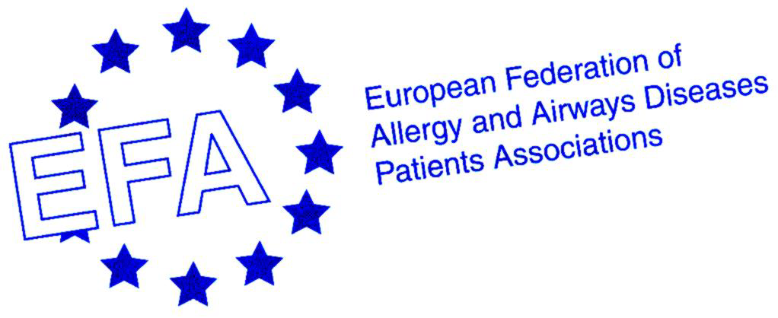
14th EFA Conference

Towards Equal Access to Healthcare for and with People with Allergy, Asthma and COPD – The Case of Reimbursement and Health Technology Assessment

28-29 May 2010

REGISTRATION FORM

DELEGATE
First name: |  |  |  |  |  | Last name: |  |  |  |  |  | Title:
Organisation:
Street:
Postal code: |  |  |  |  | City: |  |  |  |  |  | Country:
Tel. |  |  |  | Fax. |  |  |  |  |  | E-mail:

ACCOMPANYING PERSONS
First Name: |  | Last Name:

REGISTRATION FEES
options | Cost | Tick your choice/S
1) EARLY BIRD Registration before 30 March Participant Package 3 nights | € 350,00
2) Participant Package 3 nights after 30 March | € 400,00
3) Participant Package 3 nights sharing room for 2 | € 300,00
4) Accompanying person package 3 nights | € 150,00
5) EARLY BIRD Registration before 30 March Participant Package 2 nights | € 270,00
6) Participant Package 2 nights after 30 March | € 320,00
7) Participant Package 1 night | € 200,00
 | TOTAL in €

1&2 Includes 3 nights accommodation (IN: 27 May – OUT: 30 May) in a single room including breakfast, registration, conference documentation, 2 lunches, dinner, reception and 4 coffee breaks.
3) Includes 3 nights accommodation (IN: 27 May – OUT 30 May) in a room with another person including breakfast, registration, conference documentation, 2 lunches, dinner, reception and 4 coffee breaks.
4) Includes 3 nights accommodation (IN: 27 May – OUT 30 May) in double room with the conference delegate and dinner & reception
5&6) Includes 2 nights accommodation (IN: 27/28 May – OUT: 29/30 May) in a single room including breakfast, registration, conference documentation, 2 lunches, dinner, reception and coffee breaks.
7) Includes 1 night accommodation (IN: 28/29 May – OUT: 29/30 May) in a single room including breakfast, registration, conference documentation, 1 lunch, dinner or reception and 2 coffee breaks

ACCOMMODATION BOOKING DETAILS (Please complete)
Arrival date: |  | Departure date:

SPECIAL REQUIREMENTS
Double room □ | OR twin-bedded room □
Vegetarian/ allergies…:

PAYMENT and REGISTRATION DETAILS
Please send a bank transfer to the following account:
Name of account holder: European Federation of Allergy and Airways Diseases Patients Associations
Bank: Banque et Caisse d’Epargne de l’Etat
Address: 450 Route de Thionville, L-5886 Hesperange, GD Luxembourg
Account number: 0038/4174-7
Swift code: BCEELULL; IBAN: LU94 0019 0038 4174 7000
On the bank transfer please write your first and last name and “14th EFA Conference 2010”.
Please send a copy of the bank transfer statement, together with the signed registration form, by email info@efanet.org or fax to +32 (0)2 218 3141. Registration will be confirmed only after receipt of the bank transfer statement.

Cancellation policy (Cancellations must be received in writing). Cancellations must be notified in writing to info@efanet.org notified up to 23rd April entitled to a refund of the total amount paid less Euro 50 cancellation fee. We regret that refunds cannot be made for cancellations notified after 23rd April.

Please tick if you require an invoice: □

Enquiries about the Programme and stay in Lithuania should be addressed to: lina.buzermaniene@efanet.org

We look forward to welcoming you!

