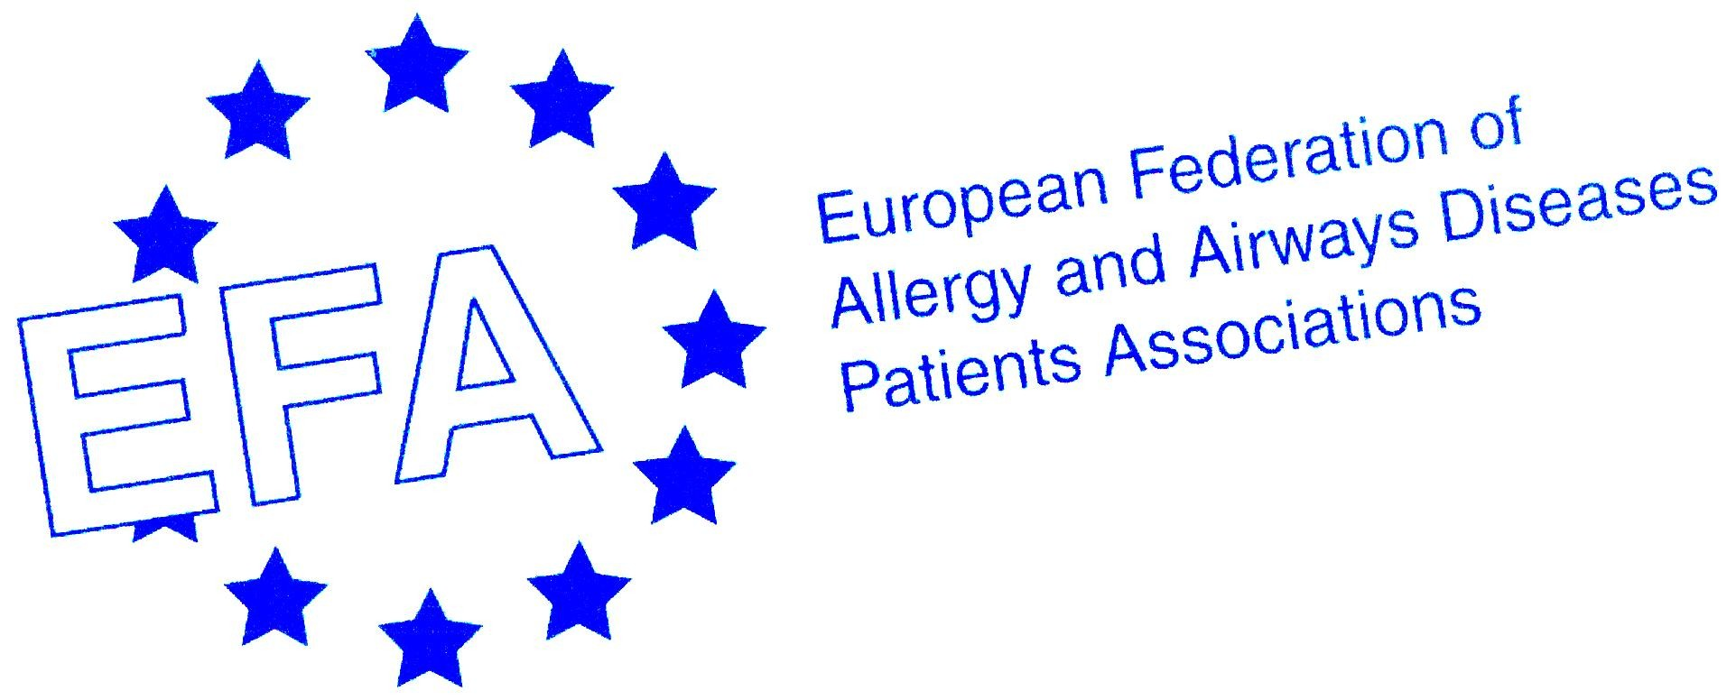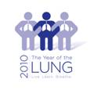

14th EFA Conference and Annual General Meeting
In Memory of Mariadelaide Franchi
Towards equal access to health care all over Europe for and with people with allergy, asthma & COPD
The Case of Re-imbursement and Health Technology Assessment

Programme
May 28-29, 2010, Vilnius, Lithuania

Venue and accommodation: Hotel Artis, Liejyklos St 11/23, Vilnius
http://www.centrum.lt/en/hotel-artis-centrum-hotels-vilnius.php

May 28th
9.00-16.00/17.00 EFA Annual General Meeting of Members (separate programme)
16.00/17.00-17.00/18.00 Networking reception, Hotel Artis
19.00-22.00 Dinner (restaurant tbc)

May 29th
First session: Reimbursement

Chairpersons:
Georg Schaeppi, Director aha! Schweizerisches Zentrum für Allergie, Haut und Asthma, Switzerland
Francisco Javier Braña , Professor Departamento de Economía Aplicada, Universidad de Salamanca, Spain

8.30-9.20 Involvement of patient organizations in reimbursement decisions
- Lithuania: Lina Buzermaniene, Lithuanian Council of Asthma Clubs
- Portugal: Luis Miguel Vieira de Araujo, Portugese Asthma Patients Associations (APA)
- France: Christine Rolland, Association Asthme & Allergies
- Bulgaria: Nikoleta Grigorova, Past President, Association of Bulgarians with Bronchial Asthma ABBA
- Sweden: Per-Åke Wecksell, Vice-President of Swedish Asthma and Allergy Association

9.20-9.40 How is reimbursement of pharmaceutical products achieved?
Manfred Caeser, Expert on market access; Easton Associates, Germany

9.40-10.00 Reimbursement, HTA, and Regulatory Agencies modalities of increased co-operation
Arnold van Halteren, Pharmaceutic Reimbursement Manager of the Dutch Health Insurance Board (CVZ), Amsterdam, The Netherlands

10.00-10.30 Coffee break

Reimbursement practice and development in selected countries and patient involvement
10.30-10.50 Reimbursement practice and development in Sweden (Swedish Medicines Agency)
(tbc)

10.50-11.10 Reimbursement practice and development in Germany
Alric Rüther, Head of Department of Quality in Health Care, Institute For Quality and Efficiency in Health Care (IQWIG), Germany

11.10-11.30 Reimbursement practice and development in Italy
Fabrizio Gianfrate, Professor of Health Economics and Pharmaceutical Management, University of Ferrara, Italy

11.30-11.50 Reimbursement practice and development in France
Matthias Brunn, Research Fellow, Paris Health Economics and Health Services Research Unit (URC Eco), University of Paris, France.

11.50-12.30 Discussion

12.30-13.15 Lunch

Second session:
13.15-14.00 Industry session (offered to EFA sustainable funding partners in between the EFA main programme-non-promotional)
Alternatively COPD book presentation.

14.00-14.30 Coffee break

Third session: Health technology assessment (HTA)
Chairpersons: Albert Jovell and/or Maria Navarro, Spanish Patients’ Forum

14.30-14.50 Introduction to HTA
Albert Jovell

14.50-15.20 Good practice in involving patients in HTA
Maria Navarro

15.20-15.40 Patient reported outcomes (PRO), Quality of life, Quality Adjusted Life Years (QALYs)
Albert Jovell and/or Maria Navarro

15.40-16.30 Countries workshop on patient involvement in HTA today and tomorrow
Two parallel workshops 1. Big patient groups 2. Small patient groups moderated by Albert Jovell and/or Maria Navarro supported by rapporteurs

16.30 Conclusions and closing of the Conference

