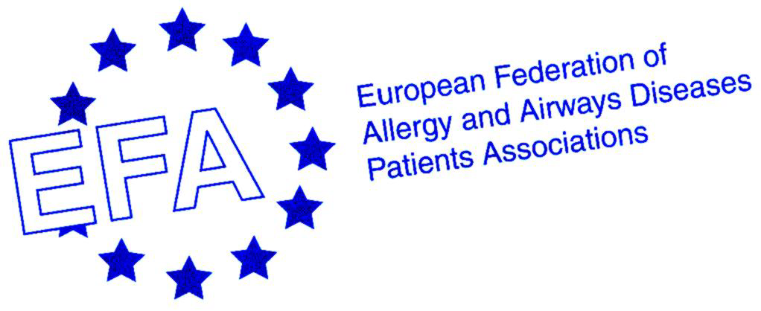

12th EFA Conference

The 5th Conference of the Polish Federation of Asthma, Allergy, and COPD Patients Associations

Education in Allergy, Asthma and Chronic Obstructive Pulmonary Disease

25 – 28 June, Warsaw, Poland

REGISTRATION FORM

DELEGATE

First Name: ___________________________ Last name: _________________________ Title: _____________
Organization: _______________________________________________________________________________
Street: ____________________________________________________________________________________
Postal Code: _______________ City: ___________________________ Country: ________________________
Phone: __________________ Fax: __________________________ E-Mail: ____________________________

ACCOMPANYING PERSONS

First Name: _________________________________ Last Name: _____________________________________

REGISTRATION FEES

Registration Fee | Cost
Participant package¹ | €540
Accompanying person package 1² | €350
Accompanying person package 2³ | €250
1-Day ticket⁴ | € 50
Sub-total ___________

¹Includes 3 nights accommodation (IN: 25 June – OUT: 28 June) in a single room in the Novotel Hotel, conference documentation, admittance to scientific events, 2 lunches and coffee breaks.
²Includes 3 nights accommodation (IN: 25 June – OUT: 28 June) in a room with another person in the Novotel Hotel, conference documentation, admittance to scientific events, 2 lunches and coffee breaks.
³Includes 3 nights accommodation (IN: 25 June – OUT 28 June) in a room with another person in the Novotel Hotel.
⁴Includes conference documentation, admittance to scientific events, 1 lunch and coffee breaks.

EXTRA NIGHTS ACCOMMODATION

Single room: €133/night 􀂅; double room €148/night 􀂅 (Taxes included)

I require ________ extra nights accommodation

Sub-total __________

GRAND TOTAL: _____________

ACCOMMODATION BOOKING DETAILS (Please complete)

Arrival date ____________; Departure date _____________

SPECIAL REQUIREMENTS

Double room □ OR twin-bedded room □

Vegetarian/ allergies ...... _________________________

PAYMENT DETAILS

Please send a bank transfer to the following account:

Name of account holder: European Federation of Allergy and Airways Diseases Patients Associations

Bank: Banque et Caisse d’Epargne de l’Etat

Address: 450 Route de Thionville, L-5886 Hesperange, GD Luxembourg

Account number: 0038/4174-7

Swift code: BCEELULL; IBAN: LU94 0019 0038 4174 7000

On the bank transfer please write your first and last name and “12th EFA Conference 2008”.
Please send a copy of the bank transfer statement, together with the signed registration form, by email or fax to +39 081 2296037. Registration will be confirmed only after receipt of the bank transfer statement.

Cancellation policy (Cancellations must be received in writing). Cancellations must be notified in writing to Scientific Communication srl. Cancellations notified up to 9th June entitled to a refund of the total amount paid less Euro 50 cancellation fee. We regret that refunds cannot be made for cancellations notified after 9th June.

Please tick if you require an invoice: □

Scientific secretariat and registration handling agency: Scientific Communication srl, via E. Quagliariello 35/E, 80131 Naples, Italy. Tel: 0039 081 229 6460; fax: 00 39 081 229 6037; e-mail: info@jeangilder.it

