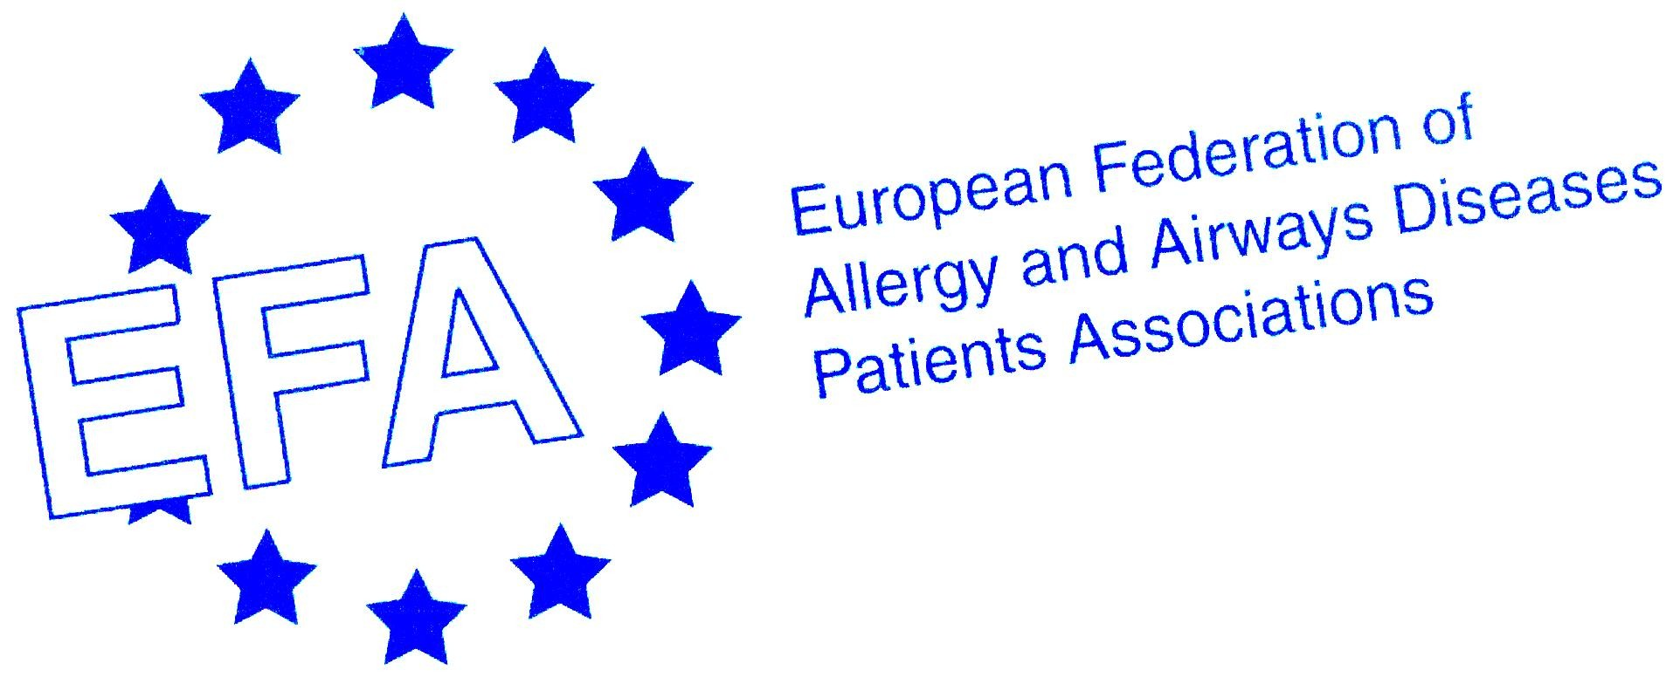

NEWS RELEASE
Embargoed until 28 March 2006 at 00:00

An Unacceptable Cost: Chronic Respiratory Diseases
WHO launches Global Alliance to fight chronic respiratory diseases

BEIJING, 28 March 2006 – Today, members of the World Health Organization (WHO) met in China for the official launch of the Global Alliance against Chronic Respiratory Diseases (GARD). GARD seeks to build awareness of chronic respiratory diseases (CRD), promote prevention against risk factors as well as improve the quality and affordability of care to patients with chronic respiratory diseases in all countries, with a particular emphasis on developing countries.
This launch, which is being attended by representatives of the European Federation of Allergy and Airways Diseases Patients Associations (EFA) is a significant step forward: until now, WHO initiatives have focused mainly on infectious diseases and this is the only WHO alliance so far to address a chronic disease.

Chronic respiratory diseases affect hundreds of millions of people in the world and account for about four million deaths per year. This disease category includes a wide range of treatable, and in some cases, preventable respiratory diseases, from asthma, respiratory allergies and chronic obstructive pulmonary disease (COPD) to occupational lung diseases and pulmonary hypertension. Common risk factors associated with chronic respiratory diseases include tobacco smoking, indoor and outdoor air pollution, allergens and occupational exposure. GARD will be instrumental in bringing NGOs, local government agencies and patient groups such as EFA, together to work towards a common vision to improve global lung health on a local level.

“WHO recognized the enormous human suffering caused by chronic respiratory diseases which have a major adverse effect on social and professional life including school, cause premature deaths, create adverse economic effects on families, communities and ultimately society as a whole,” said Jean Bousquet, M.D., Chairman, GARD. ”As the prevalence and global burden of CRD is expected to increase considerably in the very near future, it is clear that immediate action is greatly needed and the cost for inaction is unacceptable.”

“The involvement of patients in this global alliance is vital”, said Svein-Erik Myrseth, EFA President. “We often hear about illnesses and how to manage them from health professionals and politicians, but it is patients who experience the diseases day in and day out whose voices need to be heard and it is for this reason that we are happy to be involved with GARD and EFA believes that this alliance will make a big impact on the health of millions of people with respiratory diseases around the world”.

GARD has three planning steps, intended to help local government agencies [ministries of health] to develop an integrated program that identifies specific population needs in an effort to formulate and adopt effective policies that can be easily implemented at the national and/or regional levels.

The first step was outlined today and involves a comprehensive program to fight chronic respiratory diseases. It includes the development of a standardized process to obtain data on CRD risk factors, disease burden, trends, quality/affordability of care and the economic burden all countries (including developed and developing countries) in an effort to define strategies and elevate CRD on the global and local health agendas (as a public health priority). Another important component of this step is health promotion and prevention to encourage countries to implement policies in order to reduce the burden of these diseases. The accurate diagnosis of chronic respiratory diseases is essential for their control since they are largely under-diagnosed.

GARD makes recommendations for providing simple and affordable strategies for the management of chronic respiratory diseases for all patients in all countries. Health priorities, geographic variability in risk factors and chronic respiratory diseases, the diversity of national health care service systems and variations in the availability and affordability of treatments all require that any recommendation should be adapted locally to ensure their appropriateness in the community in which they are applied.

The other planning steps are planned to roll out in 2008 and they include formulating and adopting policy and identifying policy implementation steps.

For further information, please contact: Sophie Kazan, sophie.kazan@efanet.org, +32 485 50 62 75
END

About the Global Alliance against Respiratory Diseases (GARD)
The Global Alliance against Chronic Respiratory Diseases (GARD) is a voluntary alliance of internationally recognized organizations, institutions, agencies and from developing and developed countries aimed at sharing expertise, identifying problems, improving collaboration between existing programs, promoting solutions, coordinating activities and working towards the common goal of fighting chronic respiratory diseases.
www.who.int/respiratory/gard/en/

About of EFA in GARD
Patient’s organizations including EFA are supporting GARD and represent a major component of the Alliance. GARD is meant to reduce the enormous human suffering from chronic respiratory diseases and allergies and will be of great importance for the patients. On the other hand, the patient’s perspective is essential to GARD development.
The European Federation of Allergy and Airways Diseases Patients’ Associations (EFA) is an alliance of 31 allergy, asthma and COPD non-profit patient organisations in 17 countries committed to improve the health, quality of care and participation of patients with these diseases throughout Europe.
www.efanet.org

