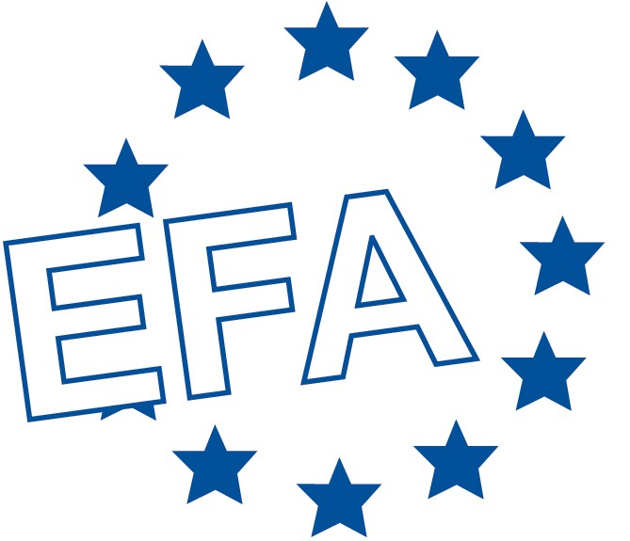

**Press Release**

**A new hope to understand the allergy epidemic: the MeDALL project**

**23 consortium members establish the project’s scientific basis**

Barcelona, January 24 – Allergy, the epidemic of the 21st century worldwide, is a major health problem and needs to be prevented and better controlled. MeDALL, a new EU-funded collaborative project to investigate the causes of allergy, is holding its kick-off meeting from January 24th to 26th 2011 in Barcelona, Spain.

MeDALL stands for “Mechanisms of the Development of ALLergy”; the project aims at improving the health of European citizens by understanding the causes of the allergy epidemic.

Per-Åke Wecksell, Board Member of the European Federation of Allergy and Airways Diseases Patients’ Associations (EFA) says: “EFA is delighted to be a partner in the MeDALL project. It is an important initiative that will help bring about some of the positive changes that EFA campaigns for; an increase in knowledge about allergies, improvement and mainstreaming of allergy management practices, and the development of prevention and understanding of allergy in Europe.”

**Allergy and environment**

MeDALL, an output of the GA2LEN (Global Allergy and Asthma European Network) Network of Excellence, will generate groundbreaking knowledge on the causes and mechanisms of allergic diseases (including asthma, allergic rhinitis, atopic dermatitis, and food allergy, particularly in children). Do environmental factors influence the development of allergies? If so, how do these factors contribute to the global allergy epidemic?

MeDALL’s first step will be based on the information gathered by previous birth cohort studies, including more than 42,000 children born between 1992 and 2007 across Europe. In a second step, 18,000 of them will be re-examined using a common protocol. The complexity of allergic disease poses a major challenge for researchers and patients alike; MeDALL’s innovative, integrative research strategy, combining approaches from systems biology to epidemiology, will help address this challenge.

**Goal: Increase knowledge and understanding**

At the first MeDALL Scientific Seminar, over 30 scientists will gather to establish the project’s scientific basis. Project Coordinator and Chairman of the Scientific Seminar Jean Bousquet (Inserm and Montpellier University, France) says: “I hope that MeDALL outcomes will hold a significant benefit for society and human interaction and environmental implications. The ultimate goal of MeDALL is to increase our knowledge and understanding of the causes of asthma and allergic disease. The results of the program will help to improve the quality of life of people with allergy across Europe, through early diagnosis, targeting primary and secondary prevention strategies and developing novel cost-effective treatments for allergic disorders.” Scientific coordinator Josep M Anto (CREAL, Barcelona, Spain) confirmed, “MeDALL combines the best research teams across Europe, who will work together to combine the data obtained in ongoing birth cohorts with systems biology in order to find innovative approaches”.

The MeDALL consortium encompasses 23 public and private institutions, including 3 European SMEs whose specific complementary scientific expertise will contribute to MeDALL objectives and patient representatives. The project is coordinated by the Institut National de la Santé et de la Recherche Medicale (INSERM), Paris, France and the Centre for Research in Environmental Epidemiology (CREAL), Barcelona, Spain. MeDALL has received funding from the European Union Seventh Framework Programme (FP7) under grant agreement n° 261357.

|  |  |
| --- | --- |
| **EFA Contact**  Patricia Murray  EFA  35 rue du Congrès  1000 Brussels  Belgium  Tel. : +32 (0)2 227 2712  Email : [info@efanet.org](mailto:info@efanet.org)  Website: [www.efanet.org](http://www.efanet.org)  **MeDALL International Media Contact**  Jane Becker  Allergy-Centre-Charité  Charitéplatz 1  D-10117 Berlin:  MeDALL PR Office  Tel.: +49-30-450 518 182  Email: [jane.becker@charite.de](mailto:jane.becker@charite.de)  Website: <http://imp.ovh.net/> |  |