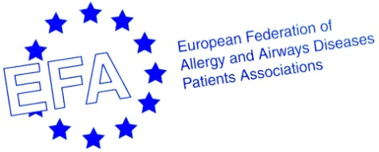
“COPD is breathlessness…being really out of breath…it took me ¾ hours to walk 250 yards (228 m)” - Allan Stone, COPD patient
17th NOVEMBER – EFA LAUNCHES VIDEO CLIP TO MARK WORLD CHRONIC OBSTRUCTIVE PULMONORY DISEASE DAY 2010
On the 17th of November, EFA, the European Federation of Allergy and Airways Diseases Patients’ Associations, is launching a video clip to mark World COPD Day 2010. The clip highlights issues surrounding COPD for patients, the medical community and policy makers, in an attempt to raise awareness of a disease which affects 44 million people in Europe, and stands to become the third leading cause of death by 2030.
“We need to make COPD known to the public…to the European people - what it is, how to prevent it…how to diagnose it early” EFA President Marianella Salapatas said. EFA believes that a strategic, integrated and comprehensive approach to dealing with COPD is urgently required at both European and national level. The EFA seven point Call To Action highlights how policy makers can act to grant greater political priority to COPD and work to combat it, by encouraging awareness, promoting earlier diagnosis, improving patient care and prevention, implementing better air quality regulation and supporting research.
The video clip presents key information on COPD, patients’ experience of living with the disease, the launch of the EFA publication on COPD in twelve European countries and the EFA Call To Action at the European Parliament in June 2010, with the contribution of MEP Catherine Stihler.
As an additional action to mark World COPD Day this year, EFA President Marianella Salapatas will speak on the 19th of November at the European Parliament Representation in Scotland at an event hosted by MEP Catherine Stihler, where officials from the Scottish Government and Parliament, campaigners and local lobby groups will discuss why COPD is such a silent killer in Scotland.
To view the video clip: http://www.efanet.org/index.php

For more information on EFA and COPD: http://www.efanet.org/copd/index.html
Contact:
For further information, please contact:
Patricia Murray
EFA, 35 rue du Congrès, 1000 Brussels
+32 (0)2 227 2712
info@efanet.org

