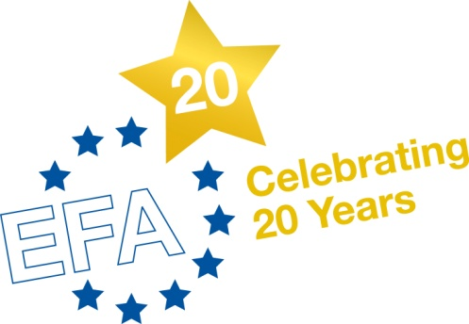

News Release
2 May 2011
Immediate Release

Art contest to show what life is like with asthma

On World Asthma Day 2011 (3 May), people with asthma and severe asthma in Europe are being encouraged to get creative for a unique art contest which will explore what it is like to live with the condition.

The contest is open to people of all ages and will help bridge the gap between doctors’ understanding of the condition and a person’s experience of it.

Asthma is a major health problem around the world. Not all types of asthma are the same and current treatments adopt a uniform approach, meaning they don’t work well for everybody.

The art contest is part of a European-wide project called U-BIOPRED*, which will help scientists understand more about severe asthma. The researchers will look at how severe asthma differs from one person to another in the hope of uncovering more effective treatments in the future.

The competition is open to any person with asthma and all types of art work from dance, music and poetry, to paintings and photography are encouraged. The top three winning entries will be displayed on the U-BIOPRED website.

The winner will be invited to the European Respiratory Society Congress in Amsterdam (24-25 September) to receive their award and see their winning entry presented at the opening ceremony.

Professor Peter Sterk, project lead, said: “The U-BIOPRED project aims to understand more about asthma and severe asthma. One important way we can do this is to hear from patients directly. This contest enables patients to express, through art, what the condition is like and how it impacts upon their life.

“The winning entry will be the piece which best conveys what it is like to have asthma and we want to hear from anyone with the condition, whether you are a budding or artist, or a complete beginner.”

Marianella Salapatas, EFA** President said: “Young, old, any age, from anywhere in Europe, this is your chance to express through art from patient to doctors what asthma is like for you in bad and/or good times.”

The closing date for all entries is 1 June 2011. You can enter the art contest by uploading a digital copy of your artwork to the website. For full terms and conditions, visit: www.ubiopred.european-lung-foundation.org/artcontest

Notes to editors:

*U-BIOPRED (Unbiased BIOmarkers in PREDiction of respiratory disease outcomes) is a research project funded by the Innovative Medicines Initiative (IMI), to understand more about severe asthma that involves universities, research institutes, the pharmaceutical industry, small companies and patient organisations.

In addition to the art contest, people can also get involved in the project by visiting their local clinical centre. For more information on the project, visit: http://www.ubiopred.european-lung-foundation.org

**The European Federation of Allergy and Airways Diseases Patients Associations (EFA) is a
European network of allergy, asthma and COPD patient organisations. EFA was created to
combine the forces of national patient associations on asthma and allergy for results at European level and to improve the health and quality of life of people in Europe with those diseases. Serving the interests of allergy and airways patients at the national level is the primary responsibility of individual members and EFA represents member organisations at European level and by facilitates
collaboration, sharing of knowledge and experiences. www.efanet.org

Media contact: Susanna Palkonen, Executive Officer, Tel +32 (0)476 373923 Email susanna.palkonen@efanet.org

