 | 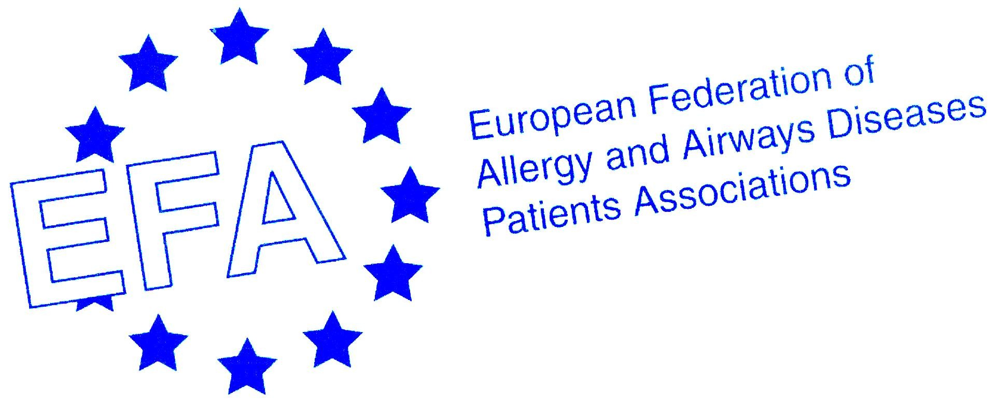 | 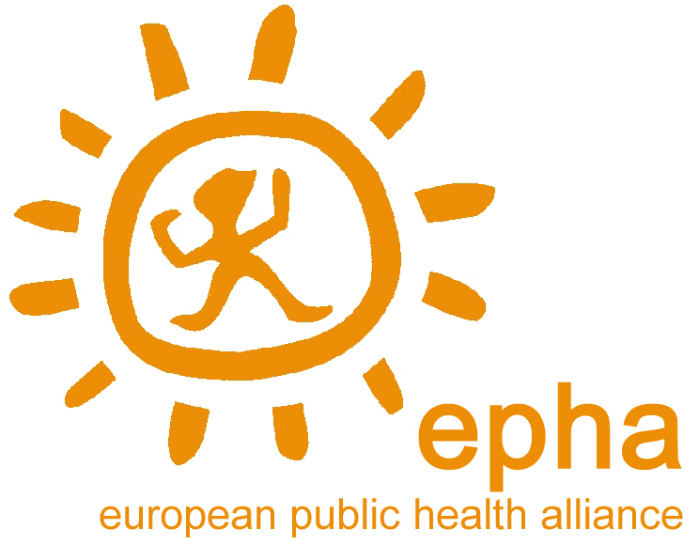

Brussels, 13 June 2006

EU THEMATIC STRATEGY ON AIR QUALITY AND
AMBIENT AIR QUALITY LEGISLATION

Dear Members of the Committee on the Environment, Public Health and Food Safety,

As you vote in the ENVI Committee on one of the most important pieces of Community environmental policy impacting on people’s health across Europe, the European Public Health Alliance, the European Federation of Allergy and Airways Disease Patients Association and EPHA Environment Network, representatives of the health, environmental health and patient community throughout Europe, ask you to ensure the highest possible level of health protection for EU citizen’s by ensuring:

Based on the new World Health Organization (WHO), Air Quality Guidelines (AQG) .

- A Higher Level of Ambition – the benefits to health even in most costly Commission impact assessment outweigh the costs by a ratio of 4:1.

Particularly for children, outdoor air pollution is associated with acute lower respiratory tract infections, asthma, allergies, low birth weight, and impaired lung function. We call upon you to uphold Parliaments consideration ‘that protecting the health of children against environment-related diseases is an essential investment with a view to ensuring adequate human and economic development.’

- No weakening of existing standards and the environmental acquis –

Flexibility on natural sources or geographical area will imply un-enforceable air quality standards and a weakening of existing standards – this is contrary to EU better regulation – 25 different interpretations of air quality directive will be impossible to implement and enforce.

The World Health Organisation (WHO) has recently published new air quality guidelines for the protection of health for which the particulate matter (PM) guidelines are:

PM₁₀: 20 μg/m³ annual mean, 50 μg/m³ 24-hour mean

The 6 Environment Action Programme mandates limit values to be based on these WHO guidelines. Without a daily limit value those suffering from cardiovascular and respiratory disease, COPD and asthma will not be protected and therefore may be hospitalized or possibly worse due to the occurrence of high levels of uncontrolled daily air pollution events.

- A new legally binding limit value or minimum 20% reduction of PM2.5 exposure.

PM_{2.5}: 10 μg/m³ annual mean, 25 μg/m³ 24-hour mean

The WHO air quality guidelines state: Although adverse effects on health cannot be entirely ruled out even below that level, [10ug/m3] the annual average WHO AQG represent levels that have been shown to be achievable in large urban areas in highly developed countries, and attainment is expected to effectively reduce the health risks.

The reduction of the adverse health effects of air pollution is an important objective where the European Union can show that it really makes a difference to people’s everyday lives. We would be very happy to provide you with more details on our position or advice from the experts within our membership and remain at your service in this regard.

Please find annexed EEN Position Paper, Air Pollution Expert letter to ENV Chair and Letter sent to Rapporteurs from health community.

Yours Sincerely,

Lara Garrido Herrero  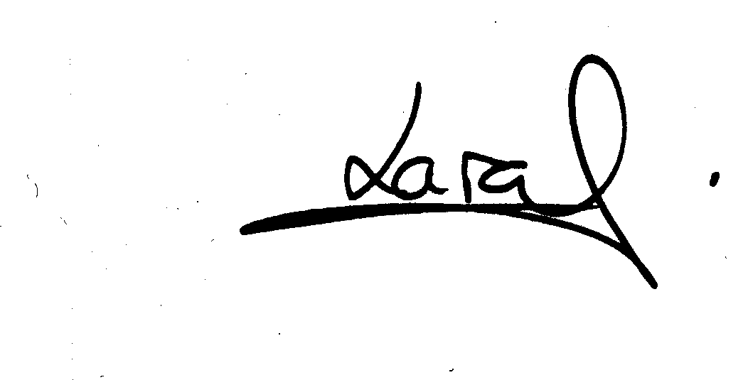  Director European Public Health Alliance (EPHA)  www.epha.org | Genon Jensen  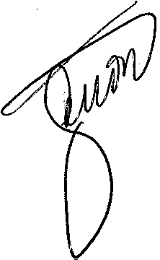  Director EPHA Environment Network (EEN)  www.env-health.org | Susanna Palkonen  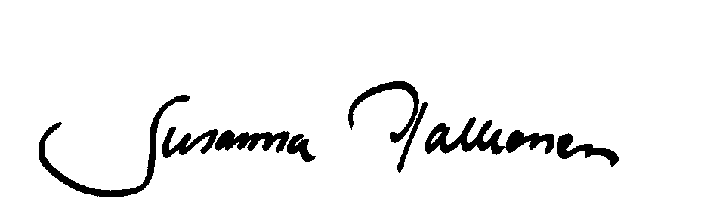  Executive Officer European Federation of Allergy and Airways Diseases Patients’ Associations (EFA) www.efanet.org

CC: Secretariat, Commission and Council

European Public Health Alliance (EPHA)
The European Public Health Alliance (EPHA) represents over 100 nongovernmental
and other notforprofit organisations working on public health in Europe. EPHA's mission is to promote and protect the health of all people living in Europe and advocate greater participation of citizens in healthrelated policy making at the European level.
Address: 39-41 rue d´Arlon, B1000 Brussels, Belgium.
Tel: +32 2 230 3056 Fax: +32 2 233 3880 Email epha@epha.org www.epha.org

European Federation of Allergy and Airways Diseases Patients' Associations (EFA)
EFA is a collaborative Network of allergy, asthma and COPD patient associations in Europe with the mission to improve the Quality of Life of people with Allergy, Asthma and COPD and of their carers throughout Europe. EFA Vision is a European Community that shares the responsibilities for substantially reducing the frequency and severity of Allergies, Asthma and COPD and recognises their social environmental, economic and health implications.
Address: EFA Central Office, Avenue Louise 327, 1050 Brussels, Belgium
Tel: +32 (0)2 646 9945 Fax. +32 (0)2 646 4116 Email efaoffice@skynet.be www.efanet.org

European Public Health Alliance – Environment Network (EEN)
EEN advocates protection of the environment as a means to improving the health and well being for European citizens. Launched in 2004, it brings together groups that want to ensure that health is at the centre of environment issues. Member groups include NGOs specialising in public health, environment related health conditions and women’s environmental and health concerns and associations representing health care and environmental professionals. One of EEN’s key objectives is to bring health expertise to the environment policymaking process.
Address: 28 Boulevard Charlemagne, B-1000 Brussels, Belgium
Tel: + 32 2 234 3640 Fax: +32 2 234 3649 Email info@env-health.org www.envhealth.org

WHO air quality guidelines global update 2005 Report on a Working Group meeting, Bonn, Germany, 18-20 October 2005 http://www.euro.who.int/Document/E87950.pdf
European Parliament resolution on a European Environment and Health Strategy (COM(2003) 338 – C5-0551/2003 – 2003/2222(INI))
Decision No 1600/2002/EC of the European Parliament and of the Council of 22 July 2002 laying down the Sixth Community Environment Action Programme, published in OJ L 242 of 10/9/2002 Article 7(1).

