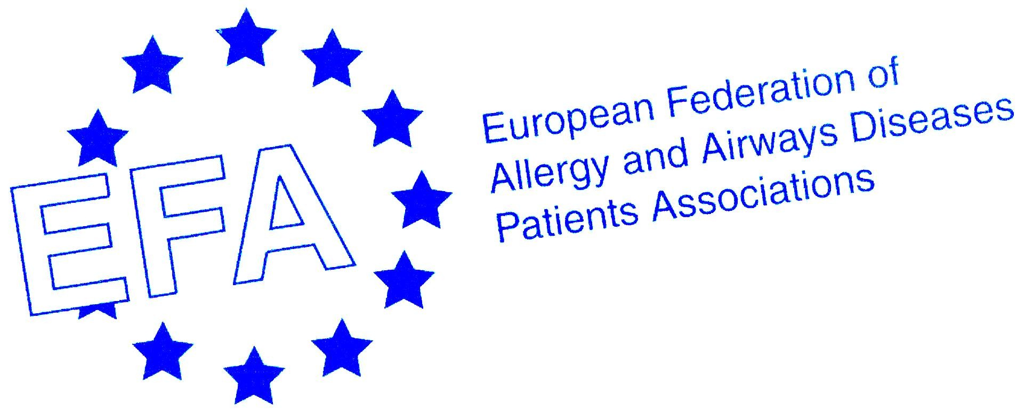
News Release
EMBARGOED UNTIL 00:01, 19th SEPTEMBER 2005

European Respiratory Society 15th Annual Congress

European asthma patients living in isolation and fear of fatal attack
Patient perspectives voiced in new European severe asthma report

Monday, 19 September, 2005 – The European Federation of Allergy and Airways Diseases Patients’ Associations (EFA) launches a new report into severe asthma today. It alarmingly reveals that millions of Europeans suffer from uncontrolled asthma symptoms which are so serious that they not only significantly impact on their quality of life, but also cause fear, isolation and social exclusion.¹

The first report of its kind, “Fighting for breath” – A European patient perspective on severe asthma investigates and highlights the challenges and impact of severe asthma on people from across Europe. The report showed that at least 1.5 million Europeans with severe asthma are living in constant fear that an asthma attack will kill them and that a quarter has speech limiting attacks at least once a week.

”The report echoed our fears,” says Martin Dockrell, Assistant Director, Policy & Public Affairs, Asthma UK, the author of the EFA report. “People with severe asthma are suffering symptoms which have a significant impact on their home and work life – they have reduced capacity for personal and economic fulfilment aggravating their sense of isolation and exclusion. The social, physical and psychological impact of asthma slices away at people’s well-being, undermining their capacity to take control of their own asthma”.

The report highlights that patients’ personal lives, social lives and careers were significantly affected by their asthma. Exposure to fumes or smoke can result in the need for absence from work, disrupted sleep and poor performance. One in five report losing out on job opportunities and 9 percent think their illness has cost them a promotion. Some people commented that they even had to leave their jobs or retire early.

Beside the impact on working life, for many, personal relationships are severely affected, or even considered impossible, as highlighted by two people from the UK who were interviewed as part of the study.
“My husband and I have separate bedrooms because he can’t get any sleep” ...“I don’t have a partner, because who would want to put up with me coughing all night and bringing up phlegm?”

Almost 70 percent miss out on physical activity saying it stops them enjoying sport, dancing, hiking and other physical activities. More than one in three commented that their asthma affects their social life. “Most places you go have smokers and many places have very small non-smoking areas, or people just don’t care and smoke next to you,” said one severe asthma patient from Spain.

The report revealed that around half of people with severe asthma in Europe are not even close to meeting international treatment goals as outlined in international GINA (Global Initiative for Asthma) treatment targets,² and as many as 90 percent are missing at least one of the five recommended treatment goals. There is little optimism about future improvements in care. Less than half of participants expected that their national healthcare system would be providing better asthma care in the next five years, and 11 percent expected the standard to worsen. More optimistically, 71 percent expected improvements to come from a better choice of asthma medicines. Moreover, the research also suggests that patients want to take fewer drugs and use less inhalers to treat their condition.

The survey involved 1,300 patients in five countries with a high prevalence of asthma (France, Germany, Spain, Sweden and the UK) and was conducted for EFA by NOP World Health in conjunction with Asthma UK and other leading patient organisations in the countries concerned. In conjunction with the survey, an epidemiological review of prevalence, hospital admission and mortality data was conducted to compare the situation across Europe. This highlighted an alarming gap in surveillance data recorded by national governments in addition to striking differences in management and the way the disease manifests itself from country to country.

Svein-Erik Myrseth, EFA President, says: “There is a need for higher prioritisation of asthma by national governments around Europe, including improvements in research, information and funding of this chronic condition. We need to empower people with severe asthma by calling for greater awareness and understanding of asthma and building patient physician partnerships. EFA believes that health professionals have an important role to play in explaining the goals of asthma management, discussing patients’ expectations, developing personalised action plans and proactively enquiring about patients’ symptoms, quality of life and expectations. We also want to see governments and health authorities providing affordable, good quality care, including access to specialist healthcare and enforcing legislation on environmental pollution to provide greater protection for those with respiratory conditions. Most of all, people with severe asthma need to be listened to. “

- Ends -
Notes to Editors:
The aim of the report, Fighting for breath: a European patient perspective on severe asthma, was to give a voice to the people across Europe who endure the severe, yet largely preventable burden of asthma.

The report brought together three distinct kinds of data: analysis of existing epidemiological data, and qualitative investigation and quantitative data from a study involving 1,300 people with severe asthma in France, Spain, Germany, Sweden and the UK. The survey was conducted by NOP World Health on behalf of EFA and the epidemiological review by the Lung and Asthma Information Agency at St George’s, University of London.

The European Federation of Allergy and Airways Diseases Patients’ Associations (EFA) is a Brussels-based alliance of 41 patient organisations in 23 countries, whose overall aim is “to improve the quality of life of people with asthma, chronic obstructive pulmonary disease and allergy, and of their carers throughout Europe.”
EFA, Central Office, Avenue Louise 327, 1050 Brussels, Belgium.
Efaoffice@skynet.be; www.efanet.org

The report was supported with an educational grant from Novartis.
EFA wishes to thank the following organisations for their participation and support:
- UK: Asthma UK
- France: Association Asthme & Allergies
- Germany: Deutscher Allergie- und Asthmabund e.V. DAAB
- Spain: Asociación de Asmaticos Madrileños
- Sweden: Astma- och Allergiförbundet
For further information or to arrange a media interview, please contact:
Jemima Warrack Sophie Kazan
Chandler Chicco Agency EFA press office
Tel: +44 (0) 207 318 8308/ +44 (0) 7815 904975 Tel: +32 (0)2 646 9945/(0) 4 85 50 62 75
Fax: +44 (0) 207 318 8349 Fax +32 (0)2 646 4116
e-mail: j.warrack@cca-uk.com e-mail: sophie@pinkpoppy.com

References:
- Fighting for breath: a European patient perspective on severe asthma, ERS 15th Annual Congress, 2005, September 2005
- GINA guidelines – www.ginaasthma.com/GuidelineList.asp?I1=2&12=1

