European Federation of Allergy and Airways

Diseases Patients’ Associations

Framework for Sustainable
Corporate Partnership

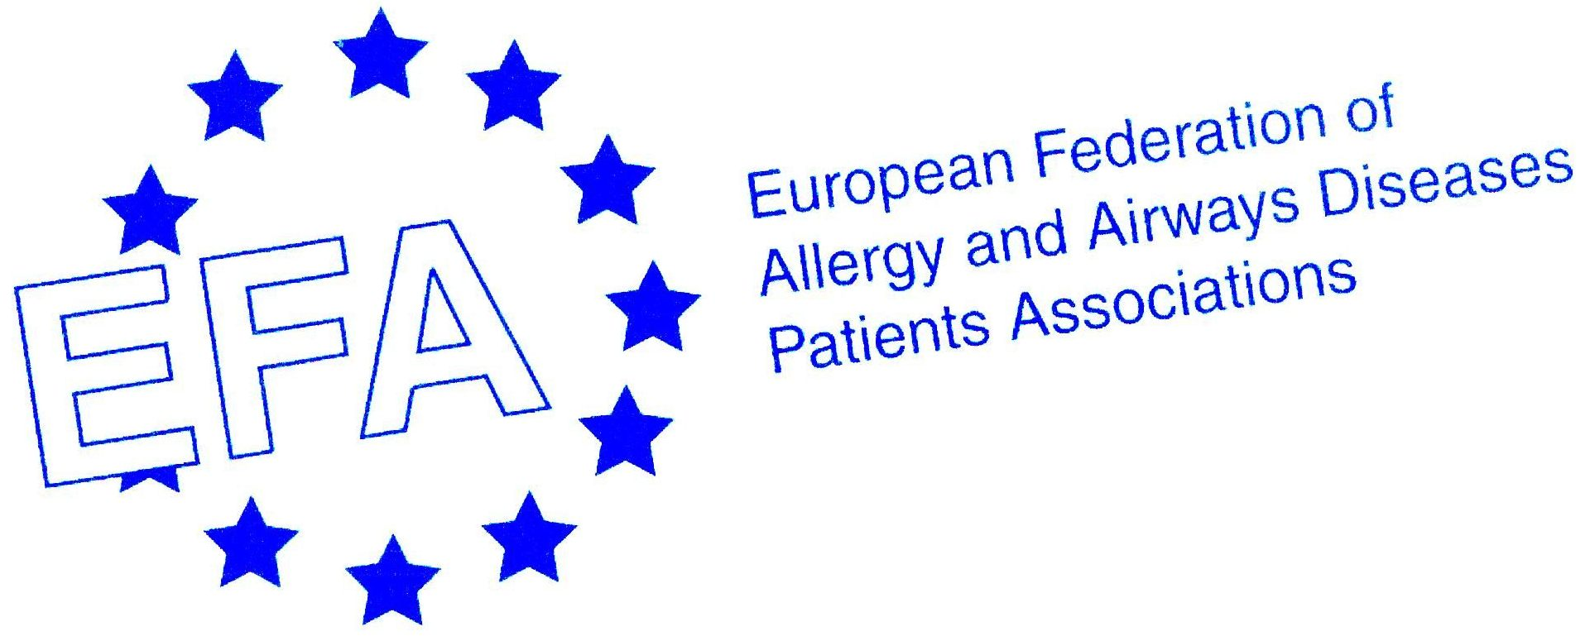

EFA Framework for Sustainable Corporate Partnerships, June 2009

Contents

Background 3

General premise of all Sustainable Partnership Arrangements
With Industry Collaboration 3

Who are Sustainable Corporate Partners 3

How the Sustainable Relationship Works 3

Sustainable Corporate Partners Financial Support 4

Sustainable Corporate Partners Benefits 5

Sustainable Corporate Partners Support Opportunities 6

Principles for Support 7

Background:

The framework offered outlines of benefits to sponsors to provide EFA with unrestricted grants, giving the capacity for EFA to manage the process of policy and project initiatives by developing its own unique resources that will make it more sustainable and independent, offer a greater and more flexible ability to support members and patients with allergy, asthma and chronic obstructive pulmonary disease (COPD).

Corporate partners of EFA are making a significant contribution to support better care, participation and environment for people with allergy, asthma and COPD and prevention, from patient perspective.

The Key areas for EFA development:
Building Sustainable Capacity to
- Project activities
Allergy (incl. also Food, Eczema)
Asthma
COPD
without geographical limitations
- Project outcome transfer
- Communication management
- Policy Development
- Advocacy
- Office

General premise of all Sustainable Partnership Arrangements with
Industry Collaboration

Sustainable Corporate Partners include Industry Partners who are companies, foundations and associations who commit to providing EFA with various levels of financial support. The Corporate Framework provides a clear method which allows EFA, and its sponsors to interact and collaborate in a transparent, accountable, effective and mutually beneficial way. It provides a modus operandi to interact with sponsors whilst maintaining EFA’s own integrity and independence whoever they are.

Who are Sustainable Corporate Partners

These are companies or organisations that produce health and/or healthy environment related products and/or provide services, foundations or associations who represent the health and environment sector relevant to allergy, asthma and COPD patients or who wish to support EFA mission. These would include but not limit to health, building and construction industry, food industry, health insurers and biotechnology organisations, and associations representing such organisations.

How the Sustainable Relationship Works

The relationship is based on regular and transparent communications and dialogue.

- Liaison and communication:
Each Sustainable Partner is entitled to nominate one individual to be their representative. This nominee will receive regular update from the EFA nominated Liaison Person who will be responsible for informing Partners of the organisations activities.

- EFA Partnership Meetings
Sustainable Partners will be invited to meet with other Sustainable Partners and the Board up to two times annually, with the aim to exchange information, be updated on development of the activities of EFA and partner organisations, and to discuss emerging issues, and areas for further collaboration.

Through this unambiguous and transparent framework mutually beneficial relations will be established between allergy, asthma and COPD patient representatives and stakeholders by extensive networks. This will facilitate improved and effective communications at all levels of EU Health, environment and research agendas, ensuring that the allergy, asthma and COPD patients’ voice is financially resourced to be at the centre of the European health related debate.

This increase and diversity of funding will allow EFA to plan and deliver activities more effectively. The diversity of funds will include contributions in the form of:
- Partnership fees
- Charitable foundations
- EU project and development funds
- Donations
- In kind support, and
- Other sponsorship

Sustainable Corporate Partners Financial Support:

Sustainable Corporate Partners commit to providing EFA with regular unrestricted financial support which contributes to the capacity development.

The levels of Sustainable Corporate Partnership are based on unrestricted funds for core capacity development as follows:

Category | 2010
***** (5 Star) | > 55,000 Euro
**** (4 Star) | 40,000 Euro
*** (3 Star) | 30,000 Euro
** ( 2 Star) | 20,000 Euro
* (1 Star) | No specific amount of Euro

*** 3 star level is project level, which means a lower support does not allow to partner in EFA owned projects. * 1 star partners will be called donators.
Partners will hopefully be able to commit for three years in the Corporate Partners Framework, thus enabling budgets and effective financial planning to build long-term co-operations.

Sustainable Corporate Partner Benefits

Transparent and Accountable Framework:
The opportunity to be associated with EFA in a pan European network at the highest levels within the EU, with open communications and with clear unambiguous transparent financial arrangements to ensure support is demonstrable with tangible outcomes, whilst ensuring the independent integrity of EFA is maintained to provide a strong European patients voice for people with allergy, asthma and COPD.

Representation:
Each Sustainable Corporate Partner nominates one individual to represent them at EFA.

Communications:
The Partners’ chosen representative receives information on regular basis on EFA’s activities.

Involvement:
Sustainable Corporate Partners will be invited by EFA to meet with other Sustainable Partners and the Board up to twice annually, with the aim to exchange information and be updated on development activities of EFA, and to discuss emerging issues, and areas for further collaboration.

Policy Framework:
EFA’s policy decisions are based on consultation with members and reflect their views only. However, since policy development does not happen in isolation it is important that, information, views and knowledge would be exchanged between EFA and partners.

Priority Notice:
First notice and priority consideration will be given to Sustainable Partners for all upcoming events and sponsorship activities involving the development of membership capacity and publications, well before general release to other organisations and the public.

Involvement, attendance and acknowledgement at EFA events:
All Partners will have the opportunity to share information about the development of an annual event, sending delegates with “Observer” status and attending VIP sessions, with contributions and support acknowledged in the programme.

Priority Placement and discounted registration for EFA events:
Priority Placement and discounted registration for the Sustainable Partners’ Representative at these events which will include an audience of patient organisations and stakeholders from EU and national institutions.

Free copies of publications:
The Sustainable Partner will receive free copies of publications. These will be sent electronically as close to the date of issue as possible.

Acknowledgements:
All Sustainable Corporate Partners will automatically have the levels of their support fully acknowledged in the form of their Organisations name prominent in EFA’s Sustainable Corporate Partner documents, publicity materials and Annual Report, where appropriate. (Exception: EU financed publications).

All Sustainable Partners will be acknowledged on the EFA Website with a dedicated area which is transparent and explains the nature of collaboration between the organisations.

For EFA designed and run events and where additional contributions are made, Sustainable Corporate Partners will have additional benefits as detailed below.

Independent from the level of partnership all Sustainable Partners are invited to liaising with EFA in an open and transparent way.

The following benefits and entitlements Sustainable Partners’ receive are dependent on the level of support provided as summarised below:

Benefits for Sustainable Partners dependent on level of support | *****  5 star | ****  4 star | ***  3 star | **  2 star | *  1 star
Ability for links with the EFA Website to be made from the Corporate Sponsors general web page without any endorsements being claimed for products, policies or services | ● | ●
Meeting with the board | ● | ● | ●
First notice and priority consideration for all partnership and sponsorship activities | ●
Right to propose a new partnership opportunity | ● | ● | ●
Invitation to working groups for expert advice were appropriate | ● | ● | ●
Free copies of EFA’s publications | 25 copies | 10 copies | 5 copies | 2 copies | 1 copy
Registration fee discount at EFA Events | 2 free registrations | 1 free registration | 50% discount on one registration | 25% discount on one registration | 10% discount on one registration
Advertising (Company Add only) in Conference Booklet | Back cover free of charge or next best opportunity (First in, first served) | One page free of charge | € 1.000,- | € 1.500,- | € 2.000,-
Right to run company symposia/ session at EFA conference | (1 hour free) | € 15.000,- | € 15.000,- | € 15.000,- | ------------
Preferred position for booth at EFA conference | (First in, first served)
EFA Speaker at company organised HCP-Meetings | Free of  honorarium | € 500,- | € 1.000,- | € 1.500,-
EFA representative at Industry partner  Advisory-Board/Committee (Honorarium) | € 1.000,- | € 2.500,- | € 3.500,- | € 5.000,-

Sustainable Corporate Partner Support opportunities
Beside the benefits EFA offers the following opportunities to support EFA conferences and meetings

Translation from English into local language of venue (including technique) | € 7.000,-
Press Release and distribution | € 20.000,-
Press Conference (including press release) | € 40.000,-
Programme/ abstract book printing | € 6.000,-
Travel grants | € 2.500,- per person
Service Desk | € 2.000,-
Note pads and pencils | € 500,-
Technique plus add during break | € 5.000,-
Bags | € 2.500,-
Cultural Programme | Price on request (from € 1.000,- thereon)
Dinner | € 5.000,-
Meet and Greet Meeting in Brussels | € 22.000,-

Principles for Support

The following principles have been developed to ensure that all funds received from Sustainable Corporate Partners and all collaborative efforts with organisations are ethical and reflect positively on EFA, its members, and the organisations and associations involved:

- EFA will accept funds only for activities that are consistent with the vision and mission of the organisation, its members and patients with Allergy, Asthma and COPD. It will have the right to refuse funds from Corporate organisations that do not fit with the ethical aims of EFA as laid down in its codes of conduct or whose activities and/or reputation is likely to bring the EFA into disrepute.

- EFA will at all times maintain an independent and strong patient voice of its member organisations. The potential effects of such positions on the commercial interests of funding sources or collaboration with partner organisations will not be a relevant factor in EFA and its member decision making process.

- EFA will only accept Core Funding and sponsorships for projects when it has full unrestricted control. It will also ensure that funds received are not in competition with its national member organisations.

- EFA reserves the right and holds final approval of all uses of its name, logo and any other identifying symbols.

- EFA will accept funding for meetings or the like only if the content has been determined by the Board who legitimately represent EFA. Sponsors will not exercise control over the programme content for these events.

- EFA will not permit presentations which support a commercial product at its meeting or events core programmes, except for the presentation of independent scientific data or the general work of the organisation within the European Health Arena.

- At its meetings and events EFA will only tolerate presentations on a product or service when it is deemed important information for the target audience by EFA and is in line with the local and European law and outside EFA´s core programme (named as Company symposium or Industry Session).

- EFA will provide appropriate recognition of an organisations sponsorship, but this must not be interpreted as an endorsement of products or policies.

- EFA will have multiple organisational supports from at least three corporate organisations for its activities to avoid the appearance of an alliance with any one company / organisation, its products, and political, legal or regulatory agendas.

- EFA will ensure information is available to sponsors and partners on these ethical principles listed above.

