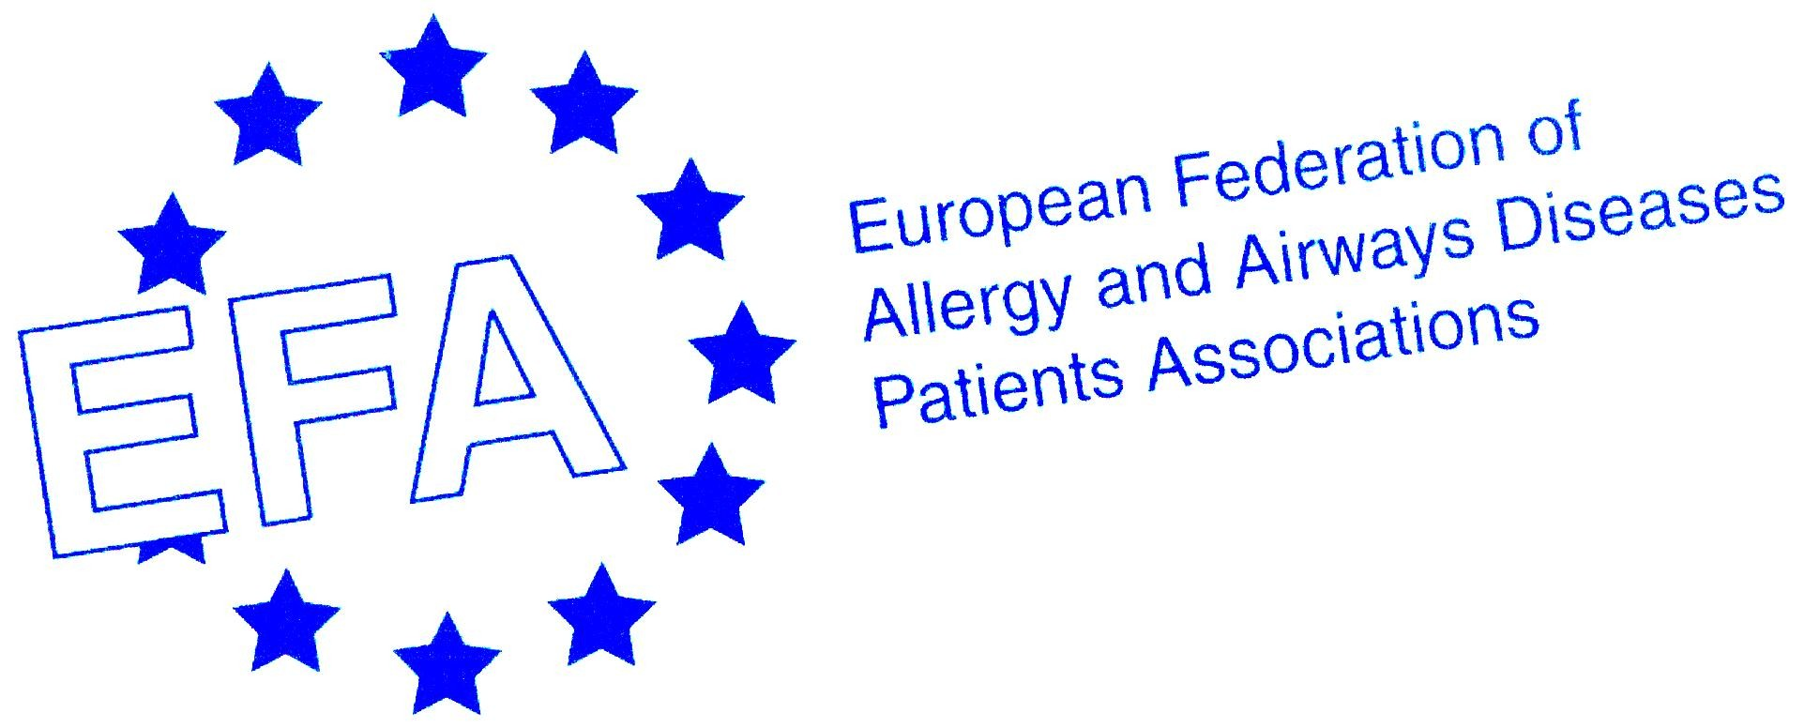

Global Alliance against Chronic Respiratory Diseases (GARD)
A Strategy for the Global Surveillance, Prevention, and Control of Chronic Respiratory Diseases

- Backgrounder -

Chronic respiratory diseases - Chronic respiratory diseases (CRD) are chronic diseases of the airways and the other structures of the lungs. Major preventable CRD include asthma and respiratory allergies, chronic obstructive pulmonary disease (COPD), occupational lung diseases and pulmonary hypertension.

Preventable CRD - Preventable CRD represent a major global health problem. Hundreds of millions of people of all ages suffer from preventable CRD in all countries. More than 500 million of these live in developing countries or deprived populations. Preventable CRD are increasing in prevalence and they have major adverse effects on the social life and disability of affected individuals; they cause premature death and create large adverse and underappreciated economic effects on families, communities, and countries. The World Health Organization (WHO) has estimated that 4 million people died prematurely of CRD in 2005 and projected that the death rate and the global burden of CRD will increase considerably in the future.

Risk factors - Many risk factors for preventable CRD have been identified and effective preventive measures can be implemented. Tobacco smoking in developed and developing countries, indoor air pollution particularly in developing countries, and also exposure to allergens, occupational exposure to toxic agents, and diseases such as schistosomiasis or sickle cell disease all cause preventable CRD.

Cost of inaction - Effective management plans have been shown to reduce the morbidity and mortality caused by CRD. Although the cost of inaction is clear and unacceptable, preventable CRD and their risk factors receive insufficient attention from the health care community, government officials, media, patients and their families.

Formation of GARD - The 53rd World Health Assembly recognized the enormous human suffering caused by CRD and requested the WHO Director General to give priority to the prevention and control of CRD, with special emphasis on developing countries. This led to the formation of the WHO Global Alliance against Chronic Respiratory Diseases (GARD).

Objectives of GARD -
- To propose a stepwise and integrated program of control of preventable CRD taking into account co-
morbidities.
- To improve collaboration between the fragmented WHO and non-WHO CRD programs that are in existence.
- To increase awareness of CRD and reduce the burden of CRD, and to foster country-specific initiatives appropriate to the local needs.
- To focus specifically on the needs developing countries and deprived populations.
- To assure the availability of affordable medications and appropriate technology for the diagnosis and monitoring of CRD,
- To train health care personnel to manage CRDs using evidence-based approaches.
- To educate and inform patients with CRDs , their care givers, and families.
GARD work approach - GARD is being developed in a stepwise approach using three planning steps which follow the WHO « Preventing Chronic Disease: a vital investment » report . It outlines a stepwise framework that ministries of health can use to create a policy and regulatory environment in which other sectors can operate successfully. This framework was developed as an integrated program with simple, tangible and attainable deliverables.
Planning Step 1: Estimate population need and advocate for action:
- Burden, Risk Factors, and Surveillance of CRD and Respiratory allergies: In all countries the burden of CRD is under-recognized and under-investigated. GARD will help the development of a standardized process to obtain data on CRD risk factors, disease burden, trends, quality and affordability of care and the economic burden that can then be compared between all countries (developed and developing) to define strategies for policy-makers.
- Awareness and Advocacy for CRD: CRD and their risk factors receive insufficient attention. There is a need to elevate CRD on the health agenda of key policymakers. All stakeholders should be involved to increase awareness on CRD. The ultimate goal of dissemination is to provide evidence that burden of CRD can be reduced.
Planning Step 2: Formulate and adopt policy: In all countries, a national policy and planning framework is essential to give chronic diseases appropriate priority and organize resources efficiently. GARD will provide the basis for action in the next 5-10 years concerning CRD with the GARD implementation plan (Figure 1).
- Health Promotion and Prevention: Risk factors for CRD are identified and countries should implement policies to reduce the burden of tobacco smoke, indoor and outdoor pollution, occupational agents and other risk factors of relevance for CRD. The cost-effectiveness and cultural/social implications of any program should be carefully evaluated before it is implemented.
- Diagnosis: In all countries, CRD are under-diagnosed. GARD will make recommendations to provide simple and affordable diagnostic tools for CRD and respiratory allergies using approaches adapted to different health needs, services, and resources as well as proper training of health professionals in their use.
- Control and Drug Accessibility: The GARD action plan should be tailored to each country’s needs, priorities, health services, and resources.
In many low-income developing countries, it is impossible and unnecessary to have specific programs for chronic diseases An integrated approach to the prevention, diagnosis, and management of CRD as proposed in the WHO Practical Approach to Lung Health (PAL); and PALSA Plus is recommended for primary care in developing countries. However, in middle-income developing countries and in developed countries, disease-specific plans already exist, and disease-specific approaches may be more appropriate.
CRD in childhood and adolescence need a separate program. In all countries, control of occupational CRD is a priority. Access to and affordability of diagnostics and drugs is an essential part of the GARD action plan.
Planning Step 3: Identify policy implementation steps
The GARD action plan needs to be implemented at national and/or regional levels. The health priorities, the resources, the geographic variability in risk factors and CRD, the diversity of national health care service systems and variations in the availability and affordability of treatments require that any recommendation should be adapted to ensure their appropriateness in the community they are applied. Implementation plans should include all stakeholders. The policy implementation follows the “Preventing Chronic Disease” report and three main planning steps should be realistically proposed and would consist of interventions that are:
- Feasible to implement with existing resources in the short term.
- Possible to implement with a realistically projected increase in, or reallocation of, resources in the medium term.
- Evidence-based and beyond the reach of existing resources.
GARD Secretariat - In the WHO Headquarters in Geneva (gard@who.int), is responsible for the management, evaluation, and monitoring of GARD initiatives.
GARD Secretariat - Nikolai Khaltaev, Geneva, Switzerland
GARD website - http://www.who.int/respiratory/gard/en/

Members of GARD include internationally recognized organizations, institutions, and agencies, including patient organisations such EFA, one of the founding members: http://www.who.int/respiratory/gard/participants/en/index.html

Members of the GARD Steering Committee and Working group chairs -
- Jean Bousquet, Montpellier, France, chair
- Ronald Dahl, Aarhus, Denmark, co-chair
- Eric Bateman, Cape Town, South Africa
- Carlos Baena-Cagnani, Cordoba, Argentina
- Michael Boland, Dublin, Ireland
- Sonia Buist, Portland, USA
- Adnan Custovic, Manchester, UK
- Leonardo Fabbri, Modena, Italy
- Yoshinosuke Fukuchi, Tokyo, Japan
- Lawrence Grouse, Seattle, USA
- Claude Lenfant, Bethesda, USA
- Ruby Pawankar, India
- Klaus Rabe, Leiden, NL
- F Estelle Simons, Winnipeg, Canada
- Archie Turnbull, Lausanne, Switzerland
- Erkka Valovirta, Turku, Finland
- Paul Van Cauwenberge, Ghent, Belgium
- Giovanni Viegi, Pisa, Italy
- Chris Van Weel, Maastrich, NL
- Sally Wenzel, Denver, USA
- Nan-shan Zhong, Guangzou, China
WHO members -
- Eva Mantzouranis, Greece
- Elisabetta Minelli
- Sahla Ottmani, Morocco
Individual experts -
- Nadia Aït-Khaled, Algeria
- Marc Humbert, France
- Jim Kiley, Bethesda, USA
- Jean Luc Malo, Montreal, Canada

Goals of GARD depending on the country development -
___________________________________________________________________________________________________________________
European Federation of Allergy and Airways Diseases Patients’ Associations (EFA)
Central Office: Avenue Louise 327, 1050 Brussels, Belgium.
Tel: +32 2 646 99 45. Fax: +32 2 646 41 16. E-mail: EFAOffice@skynet.be. Website: www.efanet.org

WHA resolution 53.17, May 2000, endorsed by all 191 WHO Member States
Prevention and Control of Chronic Respiratory Diseases at Country Level: Towards a Global Alliance against Chronic Respiratory Diseases. Geneva, June 17-19, 2004. WHO/NMH/CRA/05.1 2005.
Preventing chronic diseases: a vital investment: WHO global report. World Health Organization. October 5, 2005. htpp://www.who.int/chp/chronic_disease_report/en/ 2005.
Epping-Jordan JE, Galea G, Tukuitonga C, Beaglehole R. Preventing chronic diseases: taking stepwise action. Lancet 2005;366(9497):1667-71.
Fairall LR, Zwarenstein M, Bateman ED, Bachmann M, Lombard C, Majara BP, et al. Effect of educational outreach to nurses on tuberculosis case detection and primary care of respiratory illness: pragmatic cluster randomised controlled trial. Bmj 2005;331(7519):750-4.

