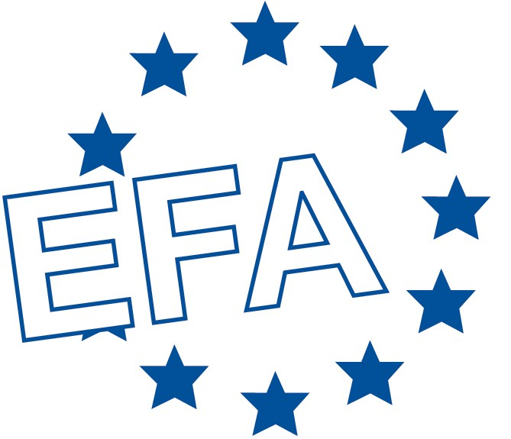
NEWS RELEASE

ALLERGIC RHINITIS PATIENTS SPEAK OUT

New Survey Reports on Impact of this Year-Round Disease which
can Affect Every Aspect of a Patient’s Life

World Allergy Congress, Munich; 28 June 2005: New survey results announced today reveal that an estimated 69.7 million allergic rhinitis patients in 11 countries across Europe are spending significant amounts of money on home interventions that they subsequently find to be inadequate. In comparison, medication is generally reported to be effective in controlling this serious disease and addressing the symptoms which can be severe.

Conducted by the European Federation of Allergy and Airways Diseases Patients’ Associations (EFA) in 11 countries, the Patient Voice Allergy Survey of 3,562 patients reveals the extent to which allergic rhinitis can disrupt people’s activities of daily living:
- Half stated that allergic rhinitis has a negative effect on work
- Schooling is affected in more than three in every ten cases
- Outdoor activities are negatively impacted in more than half
- Four in ten of those surveyed have negatively affected sleep
- Allergic rhinitis has a severe emotional impact such as irritability and fatigue in more than a third

The survey also showed that not all allergic rhinitis is the same. Of those surveyed, six in ten people suffer symptoms for at least four days per week, that last at least four consecutive weeks - these patients have what is called Persistent Allergic Rhinitis.¹ This group of patients experience far worse symptoms and allergic rhinitis has a far bigger impact on their daily living and emotional wellbeing.

Commenting on the results of the survey Dr Erkka Valovirta, EFA Medical Committee Coordinator said: “The message to patients of allergic rhinitis is clear. Visit the doctor for a proper diagnosis and for prescription medicines, which should be taken as directed at both the right dose and frequency. This way people get the maximum benefit. In addition, whilst decreasing exposure to allergens is a sensible step it should be undertaken in conjunction with a doctor’s diagnosis and advice”.

Nearly two thirds of allergic rhinitis patients in the survey also suffer from another linked allergic disease such as asthma. Of those with asthma, seven in ten patients believe it is made worse by their allergic rhinitis.

Svein-Erik Myrseth, EFA President, himself an allergic rhinitis and asthma patient, said: “Allergic rhinitis is a serious disease which can burden people for long periods of time. During a doctor’s visit I would encourage patients to talk about all their allergic diseases such as asthma, eczema and food allergies and the impact these are having on their daily life. The management of allergic rhinitis should be a partnership between healthcare professionals and the patient. There should be patient follow up and the provision of written instructions and patient education materials”.

Nearly two thirds of respondents, or their families, have made changes to their homes in an attempt to ease the symptoms of allergic rhinitis. Indeed, a fifth of responses report a spending of more than 350 Euros in the past year on such changes and a quarter said that they have spent at least 100 Euros in the past year.

Most of these interventions are regarded by respondents as ineffective. The most commonly implemented are: humidifier / air filters, considered ineffective by 79%; 70% considered replacing furniture ineffective, and 67% felt replacing soft furnishings was ineffective. Interventions far less frequently implemented by the respondents are the removal of carpets, use of pollen screens, or specialist personal hygiene products, however, of those who have used these measures, 100% find them to be ineffective. Another intervention is the use of special covers for bedding; these are found to be ineffective by 72% of those that had used them. Special bedding is perceived to be mild to moderately effective by most patients in easing symptoms; however these will only be useful for patients with a confirmed dust mite allergy.

# # #

For further information and additional background information and country-specific breakdown of the Patient Voice Allergy Survey results, please contact:

[INSERT LOCAL CONTACT DETAILS] eg:
Sophie Kazan, EFA Communications, e-mail: sophie.kazan@efanet.org
Neil Crump, Athena Medical PR, mobile: +44 (0)7778 516 206
Alexandra Gould, Athena Medical PR, tel: +44 (0)20 8956 2227, e-mail: alexandra@athenamedicalpr.com

Editor’s notes
- The Patient Voice Allergy Survey was supported by an unrestricted educational grant from UCB
- 3,562 members of an allergy patient association from 11 European countries: Belgium, Czech Republic, Finland, France, Germany, Greece, Italy, The Netherlands, Spain, Switzerland and the UK were involved
- EFA is a European network of patient organisations. EFA’s mission is to share responsibility for substantially reducing the frequency and severity of allergies, asthma and COPD, minimise their societal implications, improve health-related quality of life, ensure full citizenship of people with these conditions and at the same time, pursue equal health opportunities in the field of allergy and airways diseases in Europe. EFA’s Central Office is based at the heart of Europe, in Brussels
- Allergic rhinitis is a common inflammatory condition affecting the upper airways induced by exposure of the nasal membranes to allergens. It is characterised by symptoms such as itchy and runny nose, watery and itching eyes, sneezing and nasal congestion
- Allergic rhinitis is estimated to affect almost a quarter (24.2%) of Europeans²
- Recently introduced, the World Health Organization Initiative on Allergic Rhinitis and Its Impact on Asthma (ARIA) guidelines¹ classify allergic rhinitis as:
Intermittent – symptoms are present for less than four days per week, or for less than four weeks at a time
Persistent – symptoms are present for at least four days per week, and last at least four consecutive weeks

References
  - Bousquet J, van Cauwenberge P, Khaltaev N. ARIA Workshop Group; World Health Organization. Allergic rhinitis and its impact on asthma. J Allergy Clin Immunol 2001;108(5 Suppl):S147-334
  - Dahl R, Andersen PS, Chivato T, Valovirta E, de Monchy J. National prevalence of respiratory allergic disorders. Resp Med 2004;98:398-403

