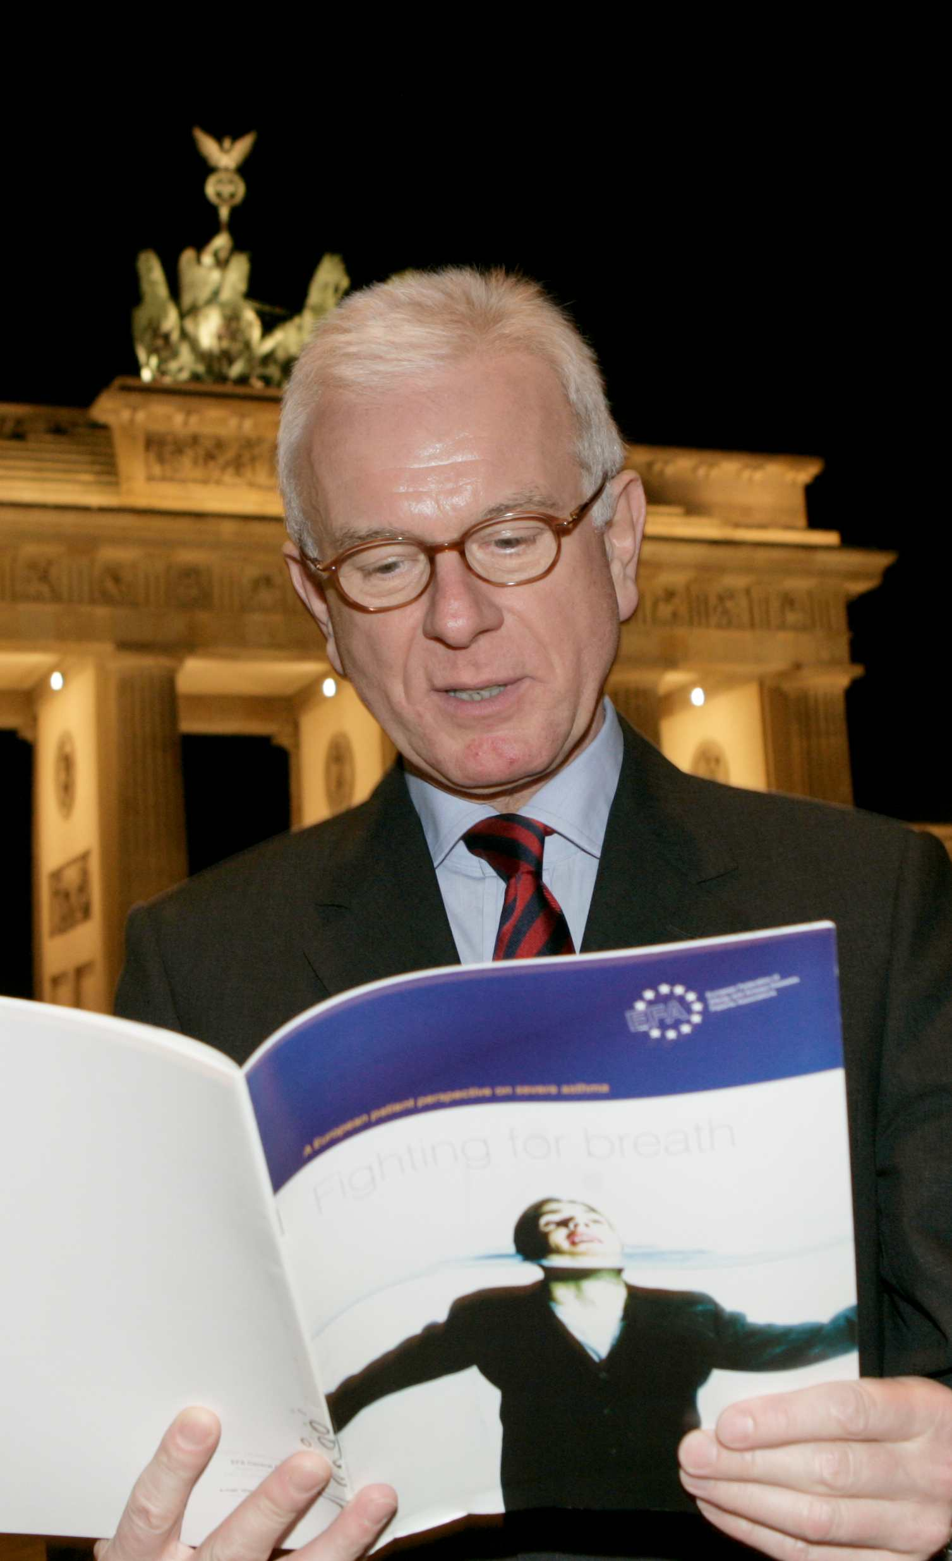

Prof. Dr. Hans-Gert Pöttering MEP, President of the European Parliament, demonstrates his support for the findings of the EFA Severe Asthma Survey ‘Fighting for Breath’ and his commitment to the need for continued improvement in the management of severe asthma across Europe.

