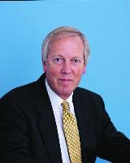

Martyn R. Partridge
Professor of Respiratory Medicine, Imperial College London

Martyn R. Partridge is Professor of Respiratory Medicine in Imperial College London, NHLI Division based at the Charing Cross Hospital, and Honorary Consultant Physician to Hammersmith Hospitals NHS Trust. His academic interests are in evaluating the delivery of respiratory health care.
Prof. Partridge is (Honorary) Chief Medical Advisor to Asthma UK (previously known as the National Asthma Campaign) and Vice President and President Elect of the British Thoracic Society. He has been involved in the British Asthma Guidelines since 1990 and is currently on the BTS / SIGN Asthma Steering and Executive committees.
He is on the Clinical Steering Committee of London Ambulance Service and is an elected member of the Council of the Royal College of Physicians and Final Year Undergraduate Coordinator for the Faculty of Medicine, Imperial College London.

