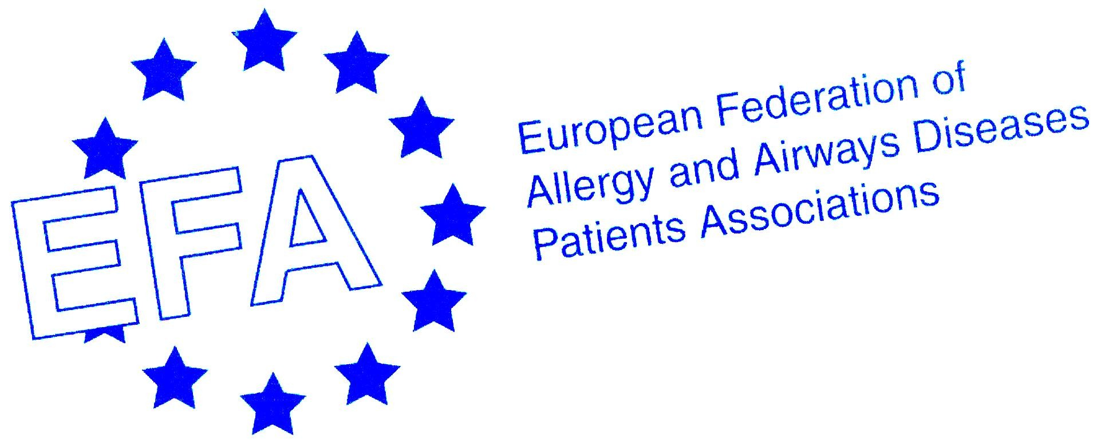

“Fighting for breath”
A European patient perspective on severe asthma

Fact Sheet

The European Federation of Allergy and Airway Disease Patients’ Associations (EFA) conducted a survey of 1,300 people with severe asthma in France, Spain, Germany, Sweden and the UK.

Highlights
The results from this shared European initiative are intended to raise awareness of severe asthma and its impact on patients in Europe.

“It is not just breathlessness, it is extremely painful … the sensation of being squashed, unable to speak, to do anything’’
- Around 1.5 million people in Europe live in fear of dying from an attack.
- One person in Western Europe dies every hour as a result of asthma¹
- Around 30 million people in Europe have asthma, and as many as 6 million suffer symptoms which are characterised as severe: that is
  - having a wheezing attack and/or sleep disturbance once a week or more often in the last year
  - one or more speech-limiting attacks in the last year
- The total cost of asthma in Europe is €17.7bn per year, and productivity lost to poor asthma control is estimated at €9.8bn per annum²

The human cost

“When I get an infection or the flu it often affects my bronchi, and I cough so violently I could crack a rib”
- Severe asthma has a substantial impact on the quality of life of sufferers. Attacks can be unpredictable, with symptoms that include “coughing,” “panic attacks,” “gasping for air,” “sweating,” “wheezing”. “Put a straw in your mouth and breathe through it,” suggests one respondent, “that’s asthma.”

- More than half the respondents say they suffer anxiety and stress because of their asthma, and one in four say that they feel their condition is “life-threatening”. The most common words used to describe asthma were “breathlessness,” “suffocation” and “fear”.
- More than one in three say their social life is restricted: almost a third say asthma stops them going on holiday; 38% say it stops them going out with friends; nearly half (49%) that they can’t have pets or visit people with pets; and 70% are no longer able to participate in physical activities.

“I can’t do activities like swimming or going to the gym. I used to like dancing a lot, but these all became too difficult”

Trigger factors

- Asthma attacks can be triggered by many environmental factors, the most common of which are air pollution, dust, pollen and cigarette smoke. Almost two-fifths of respondents say they are exposed to secondary smoke (56% in Spain).

“When I worked in day care I had colleagues who smoked and who didn’t want to open a window to clear the air because they thought it was too cold”

Social Impact

A number mentioned that they felt asthma is a condition “ignored by society.” This is because
- There is a general lack of understanding about the condition and its potential seriousness
- Sufferers are blamed, often incorrectly, for being smokers (and therefore responsible for their illness)
- Other illnesses such as diabetes have a higher profile (France)
- Environmental factors, such as pollution or smoking in public places, are only being very slowly addressed, if at all.

Current expectations

- The Global Initiative on Asthma (GINA) has issued guidelines³ setting out the standard of treatment achievable for 90% of patients, if the right medicines are used in the right way at the right time.

- Around one in four fail to meet guidelines for emergency visits, and over half experience restrictions in their daily activities.

What patients want

- Although asthma is a serious condition, EFA says 90% of the deaths could be prevented through increased public awareness, improved access to appropriate healthcare, changes in environmental and healthcare policy, and the development and availability of new more effective treatments.

- Many respondents set their hopes on the development of new drugs (71%), and nearly one in three, 29%, say investing in research is the single most useful thing their government could do to improve their asthma. Others (16%) want a ban on smoking in public places and one in ten want immediate access to specialists when necessary.

Conclusion
The EFA Fighting for Breath survey bears testimony to the impact that severe asthma symptoms place on those who suffer, their families, healthcare providers and society. EFA calls for improved EU policies and higher prioritisation of asthma by national governments around Europe to reduce this burden.

— Ends —
Notes to Editor:
The full EFA report, Fighting for Breath: A European patient perspective on severe asthma, will be launched at the ERS 15th Annual Congress on 19 September 2005 and details will be available on www.efanet.org

World Asthma Day, 2005
The theme of World Asthma Day, 3rd May 2005 was ‘The Unmet Needs of Asthma’. It aimed to get the attention of doctors and patients alike to the need for better asthma treatment and control. http://www.ginasthma.com/WADIndex.asp

Survey Methodology
Severe asthma patients were recruited if they met one or more of following criteria:
- Sleep disturbance once a week or more often in the last year
- A wheezing attack once a week or more often in the last year
- One or more speech-limiting attacks in the last year
In the UK, France and Sweden patients were recruited using random digit dialling, whereas in Germany patients were recruited by the field interviewers selecting patients randomly. In Spain patients were recruited through both doctors and field interviewers, who selected patients randomly

About EFA
The European Federation of Allergy and Airways Diseases Patients’ Associations (EFA) is a Brussels-based alliance of 43 patient organisations in 23 countries, and one of its overall aims is “to improve the quality of life of people with asthma, chronic obstructive pulmonary disease and allergy, and of their carers throughout Europe”.

EFA wishes to thank Asthma UK who carried out the research and for the participation and support of Deutcher Allergie- und Asthmabund (DAAB), Germany, Astma- och Allergiförbundet, Sweden, Association Asthme & Allergies, France, and Associación Asmaticos Madrileños ASMA, Spain.

EFA also wishes to thank Novartis, who supported the survey through an educational grant.

EFA, Central Office, Avenue Louise 327, 1050 Brussels, Belgium.
efaoffice@skynet.be; www.efanet.org

References
¹ World Health Report 2003, Shaping the Future, World Health Organisation
² European Respiratory Society. The European White Lung Book: The First Comprehensive Survey in Respiratory Health in Europe 2003
³ Global Initiative for Asthma (GINA). Pocket Guide for Asthma Management and Prevention www.ginasthma.com/GuidelineList.asp?l1=2&l2=1

