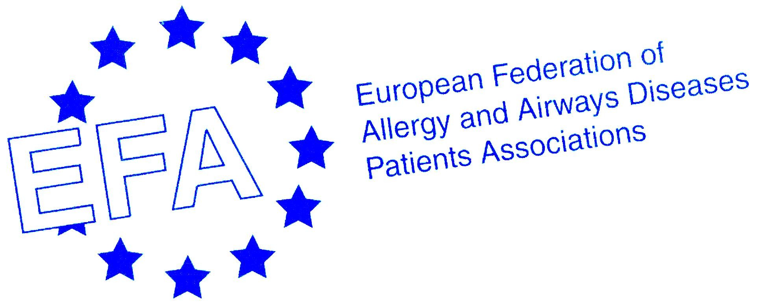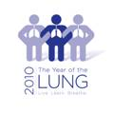

14th EFA Conference and Annual General Meeting
In Memory of Mariadelaide Franchi

Local information on Vilnius

Dear Colleagues,

We are looking forward to seeing you in Vilnius for EFA 14th Conference May 28-29 and would like to give you some practical information.

Vilnius is the capital of Lithuania. Current population of capital is about 600’000.

Local time is GMT+2 hours (same as Helsinki, Riga).

The national currency is the Lithuanian litas (LTL). The exchange rate is 1 EUR = 3,45 LTL. You can find the cash machine in the hall of Airport, in the center of Vilnius or in the bigger shopping centers or ask in your hotel.

The best way to get from airport to hotel “Artis” where you are staying is by taxi. Airport taxi “Martonas” is more expensive then taxis by phone call. To reach the hotel by Airport taxi costs about 50-60 litas – 15-17 EUR.). It would be cheaper to order taxi by phone number +37052395539 taxi “Ekipazas” while you are waiting to collect your luggage, then journey to your hotel will only cost about 20 litas (6 EUR). The operator of this taxi talks English a little bit – you have to tell them that you are at the airport and will be going to Artis Hotel.

Your hotel (and conference venue) is in the Old Town, close to many tourists attractions. Your hotel address is:
Hotel "Artis", Liejyklos St 11/23,
01120 Vilnius, Lithuania
Tel: +370 5 2660366
e-mail: artis@centrumhotels.com

Your stay in 4 star hotel “Artis” includes breakfast buffet, VAT, usage of fitness room free of charge the whole day and relaxation centre (sauna, Turkish bath, swimming pool 10 metres long with jacuzzi) in the morning hours from 7:00 a.m. till 10:00 a.m., internet (in all public areas wireless internet).

Weather in Vilnius in the end of May differs from year to year. Have your jackets and umbrellas with you. It can vary from some 14 to even over 20. 10-Day Business Travel Forecast for
Vilnius, Lithuania is available at http://www.weather.com/activities/travel/businesstraveler/
For those who are staying longer or arrive earlier, we would recommend Trakai castle tour outside of the city (see more at http://www.vilnius-tourism.lt/topic.php?tid=64&sid=100&aid=610). Trakai is a little settlement just about 28 kilometres from the centre of Vilnius. Here strategically placed in the middle of five beautiful lakes is a genuine archaic castle on water nearly 600 years old. This former capital of Lithuania is now a place for relaxation but also festivals of theatre and concerts. This castle is today one of the most visited historical and architectural site in Lithuania.
For those who do not want or do not have time to go out of city, here is the information about TOP 10 tourists attractions in Vilnius: http://www.vilnius-tourism.lt/topic.php?tid=64&sid=94

You’ll find more information about Vilnius and places to visit in a guide at the conference.

If you just want to get an idea what Lithuania is like, click on the links below and watch this 3 part video in English: you will really discover many interesting things
http://www.youtube.com/watch?v=NGYjRjuyoW8
http://www.youtube.com/watch?v=ZzBFMcawRRY
http://www.youtube.com/watch?v=5B_b2zKyQrk

Looking forward to seeing you all soon

Marianella Salapatas, EFA President
European Federation of Allergy and Airways Diseases Patients’ Associations

Lina Buzermaniene
Lithuanian Council of Asthma Clubs

Egle Kvedaraite
Lithuanian Association of Asthma Clubs

